Motorcycle IZH 7.107-01 and its modification. The operation manual 7.107-0000010-01 OM, OAO "«Izhmash", Izhevsk
1. INTRODUCING 3
1.1. Safety measures at exploitation of a motorcycle 3
2. GENERAL INDICATINGS 5
2.1. Opening-up of a motorcycle for exploitation 5
2.2. Launch of the engine 7
2.3. Running-in of a new motorcycle 7
3. SPECIFICATIONS AND CHARACTERISTICS 8
3.1. Shared datas 8
3.2. Engine 8
3.3. Power transmission 8
3.4. Undercarriage 9
3.5. Electric equipment 9
3.6. Refuelling capacitances 9
3.7. Adjusting data 10
3.8. Item of information on the contents of precious metals in a motorcycle 10
4. CONTROLS AND DEVICES 12
5. MAINTENANCE 15
5.1. Engine 15
5.1.1. Brief indicatings on removal of the engine 15
5.1.2. Coupling 15
5.1.3. Gear box 16
5.1.4. Disassembly and assembly of the engine 18
5.1.5. System of measured lubrication of the engine 19
5.1.6. Brief indicatings on replacement of parts of piston group 21
5.2. The power supply system also issue 22
5.2.1. Petrol crane 22
5.2.2. Carburettor 22
5.2.3. Inhaler 24
5.2.4. Silencer 24
5.3. Undercarriage 25
5.3.1. Suspension of a forward sprocket with the disk brake 25
5.3.2. Suspension of a forward sprocket with the two-jaw brake 26
5.3.3. Control pillar 27
5.3.4. Suspension of a back sprocket 27
5.3.5. Saddle with shield 28
5.3.6. Sprocket 29
5.3.7. Brake 31
5.3.8. Circuit of the drive of a back sprocket 33
5.3.9. Reduction gearbox of a speedometer 34
5.4. Electric equipment 34
5.4.1. Generator 34
5.4.2. Accumulator battery 35
5.4.3. Rectifier-voltage regulator 36
5.4.4. Installation of ignition 36
5.4.5. Switchboard electronic 36
5.4.6. Sensor of ignition 36
5.4.7. Induction coil 36
5.4.8. Ignition plug 37
5.4.9. Tip Ignition plug 37
5.4.10. Head lamp 37
5.4.11. Disconnecting switches of XOFF of brakes 38
5.4.12. Sound signal 38
5.4.13. Fuse 38
5.4.14. Interrupter of the indexes of turns 39
5.5. Kinds and periodicity of maintenance 39
5.5.1. Order of maintenance 40
5.6. Possible troubles of a motorcycle 41
6. CONSERVATION AND STORAGE 46
7. WARRANTY AND ORDER OF ASSERTION OF THE CLAIMES 47
7.1. Order and conditions of assertion of the claimes 47
The appendix 1. Addresses of servicing deports 49
The appendix 2. Weights of main assembly units 52
The appendix 3. Bearing boxs used on a motorcycle 53
The appendix 4. Glands used on a motorcycle 54
The appendix 4. Value of the moments of tightenings of screwed joints of a motorcycle 55
The appendix 5. A list of activities on before-sale to opening-up of a motorcycle 56
The appendix 6. The wiring diagram 57
The appendix 7. The scheme of the engine 59

The motorcycles are certificated on conformity to the requirements which are ensuring safety and guarding(preservation) of environment, by the Rules EEC the United Nations № 6, 10, 28, 39, 40, 41, 53, 60, 62, 81, 78 and have Endorsing such as a transport means № ROSS RU. MT26. Е00010П1.

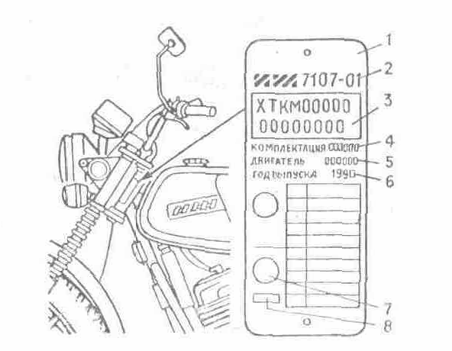
The factory plate:
1 - factory plate; 2 - trade-mark of firm - production and notation of a base midsection of a motorcycle; 3 - handle consisting from: a code of the manufacturer of a motor-item (XTKM), conditional index » models of a motorcycle (five signs), serial manufacturing number of a motorcycle (eight signs), including maiden sign - code letter conforming to year issue; 4 - notation of a complete set of model of a motorcycle; 5 - conditional index of the engine; 6 - year issue; 7 - sign of conformity at mandatory certification; 8 - code of a body by certification issuing the certificate of conformity

Dear buyer!
The firms realizing motorcycles, are obliged to conduct a complex of activities on before sale up to opening-up pursuant to a list and with the conforming mark in the coupon before sale up of opening-up.
It is necessary to test:
- a regularity of filling of the coupons № 1 and № 2 with a statement of the date of sale, availability of printing or seal of the enterprise, sale to you a motorcycle;
- unity of numbers on the engine, factory plate arranged on the cradle of a motorcycle, and in the passport of a transport means;
- complete set of a motorcycle.
To each motorcycle are applied:
- the operation manual;
- the maintenance instruction of the battery accumulative;
- the sheet of a complete set;
- complete sets of the tool, accessories and SAF (Spares And Fitting up); assembly parts;
- the passport(certificate) of a transport means (is given by firm, sale a motorcycle).
Decryption of conditional indexes
Notation of a complete set | A conditional index of model of a motorcycle | A conditional index of the engine
IZH 7.107-010-01 | 71071 | P51002
IZH 7.107-020-01 |  | P51001
IZH 7.107-025-01
IZH 7.107-030-01
IZH 7.107-040-01 |  | P51101
IZH 7.107L-020-01 |  | P51001
IZH 7.107L-025-01
IZH. 7.107-012-01 |  | P51104

1. INTRODUCING
The motorcycles of models IZH 7.107-01 (IZH a Planet 5-01) fall into to motorcycles of middle class and intended for exploitation on roads with different road cover.
The motorcycles IZH a Planet 5-01 are further retrofit of motorcycles IZH a Planet 5 with advancing of clusters and systems.
In a system of electric equipment the generator on permanent magnets, with a contact less system of ignition working irrespective of the accumulative battery, with an automatically adjustable advance of ignition is applied.
The engine is equipped with the pomp of a separate lubricating system, that has eliminated necessity of opening-up and usage in the power supply system of a motorcycle of a mix of gasoline with oil.
Gear box four-stage with an eccentric withdrawal mechanism of a clutch and reinforced motor circuit.
The brake of a forward sprocket - disk fluid-powered or two-jaw power-driven.
In suspensions of sprockets the shock-absorbers with the improved characteristics and springs of an all-clear signal, lever of the suspension of a back sprocket on rolling-contact bearings or slip are applied.
The kinematics of the drive of the brake of a back sprocket is changed.
Base model of a motorcycle: IZH 7.107-010-01 (IZH a Planet 5-01) (fig. 1).
The motorcycle IZH 7.107-020-01 is made up with the engine with a separate lubricating system, four-stage gear box, suspension of a forward sprocket with pneumo-regulation, forward disk brake, sprockets with spokesup, electric equipment with the generator on permanent magnets and contact less ignition system, independent of an accumulator battery, spring up-hydraulic shock absorber with a spring of an all-clear signal of the suspension of a back sprocket, drive of the brake of a back sprocket with a changed kinematics.
The complete sets of motorcycles differ following: IZH 7.107Л-020 - 01 - fairing up, patellar, shield and luggage compartment;
IZH 7.107-025-01 - cast sprockets;
IZH 7.107Л-025-01 - cast sprockets, fairing up, patellar shield and luggage compartment;
IZH 7.107-030-01 - two-jaw barrel brake of a forward sprocket;
IZH 7.107-040-01 - joint lubricating system of the engine and two-jaw barrel brake of a forward sprocket;
IZH 7.107-012-01 - engine with a double-tube exhaust system and two-jaw barrel brake of a forward sprocket.
The exploitation of a motorcycle, his(its) complete sets and modifications with lateral trailers VMZ 9.203, IZH 9.204 and their modifications or with a cargo module IZH 9.604Gr and its modifications is enabled.
Mounting and the features of exploitation of a motorcycle with a lateral trailer or cargo module are set up in the passports or operation manuals affixed to these items.
In connection with a permanent job on perfecting an item in a design the changes, not reflected in the present manual can be introduced.

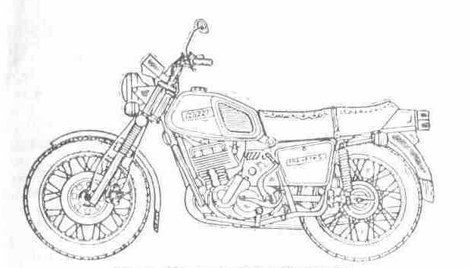
Fig. 1. A motorcycle IZH 7.107-010-01

1.1. Safety measures at exploitation of a motorcycle
Is not enabled:
- exploitation of a motorcycle on clean gasoline at a disabled system of separate lubrication;
- to touch at a running engine stripped tips or wires of a charging circuit of the generator. A charging circuit: a blue wire connecting generator, switchboard both ignition switch and pink wire - from the disconnecting switch of ignition to an emergency shut-down of the engine;
- storage of cleaning rags under the carburettor.
At usage of leaded fuel it is necessary to remember, that he is toxic, therefore before launch of the engine indoors to be convinced, that it is aerated.
To start up the engine by vigorous clicking the lever of a releaser. A leg from the lever to try to retract to the left.
Be cautious with a fire by activity with gasoline and other flammable fluids.
Incidentally pour ping at charging a surface of a motorcycle to wipe dry and only after that to launch of the engine, to monitor, that in a cavity of a casing of the carburettor was clean.
At repair of clusters of electric equipment in order to prevent a short circuit in wiring to disconnect a wire with "-" battery terminal.

2. GENERAL INDICATINGS
Starting exploitation of a motorcycle, acquaint with original positions of the present manual, in which one the rules on exploitation, order of disassembly and assembly of clusters of a motorcycle are set up.
Top condition, recoilless and durable activity of a motorcycle depend on exact exploitation, skilful and well-timed maintenance.
Against stealing up the lock with keys, the keys of the lock of ignition and key of tool boxes are in a tool box.
At launch and warm-up of the engine is not enabled, that he worked with large rotational speed of a crankshaft, as it can result in anticipatory wearing of parts and mortality of the engine.
In order to prevent an overheating of the engine the long time on I and II transmissions is not recommended to go. Switching from maximum transmission on lowest to do in time, not enabling overload of the engine.
The lever of a fuel corrector of the carburettor recommends to use at launch of the cold engine, at motion on high speeds or considerable motor loads. In remaining cases the needle of a corrector of the carburettor should be lowered by turn of the lever counter-clockwise.
On a slippery road it is not recommended to squeeze out coupling and sharply to brake. The often stops and driving the lowest transmissions augment propellant consumption. Abandon a motorcycle at rest, it is necessary to bar petrol crane, as the hit of a plenty of fuel in crankshaftuping the chamber can call "throwup" Ignition plug and will hamper launch of the engine.
At inhibition it is recommended to use simultaneously brakes of forward and back sprockets.
It is forbidden to put on a saddle of a motorcycle an accumulator battery, it is necessary to avoid hit of gasoline and oil on a jacket of a saddle.
It is recommended the coloured surfaces to wash water, to not dust off and mud from a surface by dry cleaning rags, to not apply to placer mining soda salt, kerosene, gasoline and seawater. It is recommended in batches to apply to preservation of luster of the coloured surface a glazing structure.
For elimination of injured places of colouring a surface to clean closed-grained sandpaperup to wipe by cleaning rags, wetted in clean gasoline, to colour by an enamel and to dry.
Jelled enamel to dilute by a solvent.

2.1. Opening-up of a motorcycle for exploitation
If your motorcycle has not passed before salup opening-up, before the beginning of exploitation of a new motorcycle to make following:
- to unpack a motorcycle;
- to establish a control surface and ignition switch on a upper bridge and to fix by nuts;
- to eliminate lubrication from a surface by cleaning rags, wetted in kerosene or mineral spirit, and to wipe dry;
- to disconnect a rope of coupling from a control surface to arrange it between a upper bridge and shield of devices, to connect a rope to a control surface;
- removeup a screw from a bracket of coupling, on its place to establish a mirror and to fix by nuts;
- to disconnect a flexible roller of a speedometer from reduction-gear housings;
- to remove shield of devices with technological brackets;
- to remove technological brackets with shield of devices;
- to connect chockup connectors shield of devices to a main bundle and bundle of switches, having paid attention to a regularity of connection of chocks to bar to boat connection by rubber jackets;
- to ease nuts of attachment of a upper bridge of the suspension;
- to establish shield of devices on brackets of a upper bridge;
- to establish under the left-hand bolt of attachment shield of devices a holder of a bundle (fig. 2) and to fix, shield by bolts through spacers (against the stop in strut sleeves) and to postpone the stall nuts of a upper bridge;
- to fix a main bundle by a holder, flexible roller to arrange from the dextral party between the upper and lower bridges, to connect to a speedometer;
- to establish arcs of safety in the following order:
- to paste an arc of safety I a bracket of attachment of the engine and to fix a bolt, similarly to establish the second arc;
- to establish the upper brackets on a tube of the cradle, previously having fixed their bolts on one of arcs;
- to establish the gasket between brackets and cradle and to fix arcs in the upper brackets;
- to test a level of oil in a gear box through a handhole in the left-hand cover of a casing (fig. 11);
- to remove guardss of the carburettor, having eased spreader and having turned away lateral bolts;
- to slosh oil in an air cleaner (see section "the power supply system and issue");
- to establish paper clips on a petrol hose, having fixed it on unions petrol crane and carburettor;
- to establish guardss of the carburettor, reliably having fixed spreader and lateral bolts. Availability of guardss of the carburettor and tightening of bolts considerably reduce a vibration level of a motorcycle;
- to make a visual inspection of a motorcycle to check for security of attachment of all screwed joints, braking action, control mechanisms, autopodiums - signal, turn indicators, pressure I trunks, at necessity pump a hydraulic drive of the brake of a forward sprocket, to test reliability of activity of brakes (see section "of Brake");

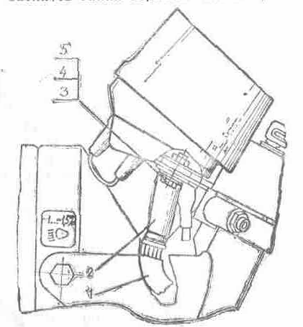
Fig. 2. A holder of a bundle:
1 - main bundle; 2 - holder of a control surface; 3 - bolt; 4 - spacer; 5 - bush spreader

- to make charging the petrol tank by gasoline or in case of absence of a system of separate lubrication by a mix of gasoline with oil (see tab. 2); the notice. At charging to not add gasoline on 40... 50 mms up to a sill of a port of the petrol tank with the count of heat expansion of gasoline.
- to slosh oil (see tab. 2) in oily capacitance through an inundated port which is blanked off (see section « a System of separate lubrication »).
- to test availability of oil in a transparent oil line going from an oil pump to an inlet pipe of the engine, if necessary to make accelerated filling (see section “a System of separate lubrication of the engine “), previously having tested a tightening of unions;
- if forward lanterns(canopies) - the turn indicators established in brackets arranged on a back surface of a lower bridge, it is necessary: to remove lanterns, to disconnect them from a main bundle and from a spacer - "«weight", to rearrange brackets under the head of bolts, to fix lanterns by nuts, to connect wires to a main bundle and with a spacer - "«weight". If the lanterns - indexes are not established on a motorcycle to fix them as is indicated in a label affixed to a complete set of lanterns;
- to test connection of wires under a saddle and to establish a saddle on a place;
- to slosh an electrolyte in an accumulator battery and to charge (see maintenance instruction affixed to accumulative accumulator battery);
- to undercut on 1,5... 2 mms the exhaust union(pipe connection) of a cover of ventilation plugs of the battery and mount up;
- a drainage handset from a complete set of accessories;
- to establish the battery in the left-hand tool box, terminal "-" to connect to "weight", terminal "+" to connect to a wire of a main bundle, end of a drainage handset to leak through a foramen of a body of a box and to attach to the cradle. In order to prevent oxidation to lubricate bolts of attachment of wires and battery terminal with petrolatum;
- to fix the battery by a hold-down tool;
- to test reliability of connection of tips and screws of attachment of wires to a rectifier - voltage regulator;
- to test activity of electric equipment;
- to make regulation of a light beam of a head lamp (fig. 34);
- to establish against stealing the lock on a control pillar (fig. 3) in the following order:
- to paste a spring 5 and pin 8 into a jack of the basis 4, welded to a control pillar; - to paste into a body 2 locks the barrel 1, a rod - fix 3 and to postpone the stall by two bolts 7 with spacers 6;
- to paste a key to turn a control surface to the right before overlapping of a pin 8 with a foramen of a lower bridge, to click the barrel 1 and to turn a key clockwise, to take out a key - lock is closed, opening out in the return order;
- having convinced in activity of the lock to postpone the stall bolts 7 before full failure of heads, that will eliminate a capability of fast disassembly of the lock by the by-standers;

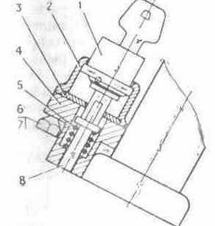
Fig. 3. against stealing the lock:
1 - barrel; 2 - body; 3 - rod - clamper; 4 - basis; 5 - spring; 6- spacers; 7 - bolt; 8 - pin

- to establish on a motorcycle of the conforming complete set fairing, patellar shield, luggage compartment (according to the affixed passports).

2.2. Launch of the engine
For launch of the engine to open petrol crane to click on drowning of a float of the carburettor and to hold it in this rule 5... 8 with before filling of the float chamber by fuel (at a restart hot of the engine to overflow the float chamber it do not recommend).
For launch of the cold engine to turn the lever of a fuel corrector 7 on a control surface (fig. 5) clockwise (to enrich the mixture), to click the lever of a decompressor 3 (fig. 4), to turn a control handle by the throttle of the carburettor on 1/4 its courses, some times to click the lever of a releaser, to bar a decompressor, to include ignition and, aggressively depressing on the lever(arm) of a releaser, to launch of the engine. In order to prevent breaking densntups of a releaser the quadrant in engagement with a ratchet is necessary for entering continuously, and then aggressively to click the lever of a releaser for launch of the engine.
After launch and warm-up of the engine on small rotational speed of a crankshaft the lever of a corrector to clear.
The motion of a motorcycle can be started only after a warm-up of the engine, when he steadily works on small rotational speed of a crankshaft at a closed corrector.
For launch hot of the engine it is enough to include ignition and aggressively to click the lever of a releaser.
With the purpose of exception of graze of the lever of the firing gear for a cover of a tool box a leg from the lever of a releaser to retract to the left (from a motorcycle).
At exploitation of a motorcycle in winter time in a gear box to add 0,1... 0,15 l of gasoline.
ATTENTION! It is necessary to keep track of by system operation of lubrication on an indicating light "Oil".

2.3. Running-in of a new motorcycle
The recoilless and durable activity of a motorcycle in many respects depends on its exact exploitation in an initial stage. During running-in there is a run in of working surfaces of parts.
On a running-in period of a motorcycle in the carburettor the restraining pin of rise of the throttle established, to clean which one up to the end of running-in it is not recommended. The run of running-in of a motorcycle is established 3500 kms, after running-in to break off a restraining pin in a cover of the carburettor. At running-in to execute the following requirements: to start motion only after a warm-up of the engine, to not enable large rotational speed of a crankshaft of the engine in a warm-up time, to not overstrain the engine, to avoid driving on "«high-gravity" roads.
It is not recommended to conduct training to driving in a running-in period of a motorcycle, as it will put to a decrease of guarantee run of a motorcycle.
The table 1
Recommended running speeds of a motorcycle in a running-in period
Transmission | Speed, km/h
I | 10
II | 30
III | 40
IV | 60

3. SPECIFICATIONS AND CHARACTERISTICS

3.1. Shared datas
Base of a motorcycle (spacing interval between axes(axes) of sprockets), mm | 1450
Road lumen full-load and normal pressure in trunks, mm | 135
Critical dimensionss *, mm
Length | 2200
Width | 810
Altitude | 1200
Weight dry, kg | 158-165
Maximum load, kg | 170
Including load on a luggage compartment, kg | 20
Maximum speed, km/h | 120
Path(route) of inhibition, m from speed: 30 km/h | 6,5 (6,0) *¹
80 km/h | 42,6 (4,1) *¹
Propellant consumption at speed 90 km/h, l/100 km*² | 5,0
* The critical dimensionss are given disregarding fairing, luggage compartment, arcs of safety to a mirror.
*1 In brackets the standard for motorcycles with disk brakes are adduced.
*2 Propellant consumption is a parameter determining general availability index of product of a motorcycle and but is the standard of operational propellant consumption, which one the plant does not establish, as she depends on the operation conditions of a motorcycle.

3.2. Engine
Phylum of the engine | two-cycle single-cylinder
Cylinder bore, mm | 72
Piston stroke, mm | 85
Compression ratio | 8,2... 8,7
Displacement volume, sm3 | 346
Ultimate output of the engine at (4850 +-10 % rpm), kw (l. With.) | 15,39... 17,01 (20,9.. .23,1)
Lubricating system of the engine | separate, with an oil pump dosing submission of oil from rotational speed of a crankshaft and a motor load in ratio 1/25... 1/100 to submission of gasoline or together with gasoline a mean operational ratio of oil and gasoline depending on a complete set 1/70... 1/30
Ignition system | electronic contactless with automatic control of an ignition advance from rotational speed of a crankshaft of the engine and independent from an accumulator battery
The carburettor | K - 65I
Used fuel | gasoline with an octane rating not less than 76
Air cleaner | contact - oily
Cooling | air

3.3. Power transmission
Transmission from the engine on coupling | by a circuit drive bush two-row (reinforced)
Coupling | multi-disk in an oily bosh
Gear box | 3-arbor four-stage in one unit with the engine
Transmission from a gear box on back a sprocket | by a circuit single-row drive bush
Gear ratio from the engine on coupling | 2,17
Gear ratio from a gear box on a back sprocket | 2,33
Gear ratios of a gear box:
I transmission | 3,88
II transmission | 2,01
III transmission | 1,26
IV transmission | 1,0

3.4. Undercarriage
The cradle | tubular, welded
The suspension of a forward sprocket | of a telescopic type, with spring-hydraulic shock absorbers
The suspension of a back sprocket | lever, with spring-hydraulic shock absorbers
The size of trunks, in. (mm) | 3,50X18 (90-459)
Forward sprocket on a motorcycle 7.107-025-01 | 3,25X19 (82-484)
The brake:
Back | it is drum type
Forward | disk hydraulically-driven or two-jaw it is drum type power-driven

3.5. Electric equipment
The battery accumulative | 6MTC-9, 12В, 9A.h.
Alternator single-phase with excitation from permanent magnets | 7.107-3701010, 14 V., 90 W
Rectifier - voltage regulator or voltage regulator | BPV 21-15, electronic or RNM 1
The condenser | K50-35-63В-2200 mF-V
Ignition switch | 7.107-3704010-10
Induction coil | 7.109-3705010
The sensor of ignition | 7.110-3838200
The switchboard of ignition | 7.110-3734010-20, electronic
Ignition plug | such as A-23
Tip ignition plug | 7.107-3707160
Lantern of turn indicators | 34.3726 or 7.109-3726
The interrupter of turn indicators | IZH RP4, electronic
The switch of the signaling system | 7.107-3709010
The switch combined | 7.107-3710010-10
Head lamp | FG 137 V1 or FG 137B2
Lantern back | 171.3716
Signal sound | S 205 B
The disconnecting switch of XOFF of the brake of a back sprocket | VK 854-V
Speedometer | SP 158
The disconnecting switch of XOFF of the brake of a forward sprocket | IZH VK103
The safety device | 7.109-3722010
Shield of devices | 7.107-3805010-10

3.6. Refuelling capacitances
The table 2
The naming | A volume, l | Fuels and lubricants oils
The petrol tank | 18 | gasoline A-76, AI-93, AI-95 a GOST 2084-77, А92 the technical specifications 38.001165-87 (for motorcycles from times by an efficient lubricating system of the engine) or gasoline A-76, AI-93 in a mix with oils in a proportion 25:1: motor automobile for carburettor engines of M-8v a GOST 10541-78, motor for auto tractor diesel engines of M-10v; the GOST 8581-78, air MC-14, MC-20 a GOST 21743-76 or oils for two-cycle engines SAE 30, SAE 40, SAE 50 at the temperature of of air up to a minus 5 and SAE 15W, SAE 20W - is lower a minus 5 " With or with oil MGD-14M the technical specifications (TS) 38.101930-88 in a proportion 50:1
The gear box | 1,0 | oils of M-8v, M-10v2 or oils for engines SAE 30, SAE 40, SAE 50 at the temperature of of air up to a minus 5 С and SAE 20W, SAE 15W - is lower a minus 5 С
The engine (capacitance in the left-hand cover of a casing) | 0,75 | oils: M-8v, M10v2, MC-14, MC-20, MGD-14M or oil for two-cycle engines SAE 30, SAE 40, SAE 50 at the temperature of of air up to a minus 5 С and SAE 15W, 5АЕ 20W - is lower a minus 5 С
Air cleaner | 0,15 | oils: M-8v, M-10v2, MC-14, MC-20, MGD-14М or oil for two-cycle engines SAE 30, SAE 40, SAE 50 at the temperature of air up to a minus 5 С and SAE 15W, SAE 20W is lower a minus 5 С
Shock-absorber of the suspension of a forward sprocket with the disk brake (in each) | 0,3 | oil for hydraulic shock absorbers MGP-10 OST 38.1.54-74, oil spindle AU the technical specifications 38-1011232-89
Shock-absorber of the suspension of a forward sprocket with the two-jaw brake (in each) | 0,175 | oil for hydraulic shock absorbers MGP-10 OST 38.1.54-74, oil spindle AU the technical specifications 38-1011232-89
Shock-absorber of the suspension of a back sprocket (in each) | 0,075 | oil for hydraulic shock absorbers MGP-10 OST 38.1 54-74, oil spindle AU the technical specifications 38-1011232-89
The drive of the disk brake | 0,1 | brake fluid "Tom". The technical specifications 01-1276-82, Neva » the technical specifications 6-01-1163-78 or SAE 1703
Bearing boxs, hinges, tips and circuit of a back sprocket |  | lubrication Litol- 24 GOSTs 21250-79 or lubrication SAE 90

3.7. Adjusting data
Backlash between welding rods of an ignition plug, mm | 0.6... 0,75
Free running on the end of a clutch lever, mm | 5... 10
Free running on the end of the lever of the brake of a forward sprocket, mm | 5... 15
Free running of a pedal of the lever of the brake of a back sprocket, mm | 5... 15
Free running of shells of ropes of a metering device, throttle of the carburettor and fuel corrector, mm | 1... 2
Slack cable of the drive of a back sprocket, mm | 20... 30
Air pressure in trunks, MPa (kgs/sm²):
Sprockets forward | 0,15+0,01 (1,5+0,1)
Sprockets back | 0,21+0,01 (2,1 + 0,1)

3.8. Item of information on the contents of precious metals in a motorcycle
Name | Notation | Quantity | Weight, g | Precious metal
The interrupter of the indexes of turns | IZH RP-4 | 1 | 0,0033 | gold
The rectifier - regulator | BPV 21-15 | 1 | 0,00175 | gold
Commutator | 7.107-3734010-20 | 1 | 0,0118 | gold
The interrupter of the indexes of turns | IZH RP-4 | 1 | 0,0042 | argentum
The rectifier - regulator | BPV 21-15 | 1 | 0,1844 | argentum
Switchboard | 7.107-3734010-20 | 1 | 0,00055 | argentum
Switchboard | 7.107-3734010-20 | 1 | 0,00034 | platinum

4. CONTROLS AND DEVICES
On a control surface from a left-hand side (fig. 4) are established: a clutch lever 1, switch of the signalling system and lever of a decompressor 3.
Clutch lever.
At clicking the lever the clutch is switched off also engine is detached from a gear box. Screws adjusting to dispose a groove to a tube of a control surface.
The switch of the signalling system.
The switch of the signalling system has switches: light of a head lamp 2 with two locked positions - Short-range light and Distant light; the indexes of turn 4 with three locked positions: mean - the turn on the left, dextral - turn to the right is switched off, left-hand -; the disconnecting switch of a sound signal 5.
The lever of a decompressor.
By clicking the lever make valve crack of a decompressor for purging the barrel.
On a control surface from the dextral party (fig. 5) are established: the handle of the throttle of the carburettor 4, lever of a fuel corrector 7, lever of the brake of a forward sprocket 3, barrel of a main hydraulic drive of the brake 1, switch combined.
The lever of a fuel corrector.
At turn of the lever clockwise mix is enriched (corrector open).
The lever of the brake of a forward sprocket. The clicking the lever actuates the brake of a forward sprocket, thus the lamp of XOFF in back lanterns of a motorcycle ignites.

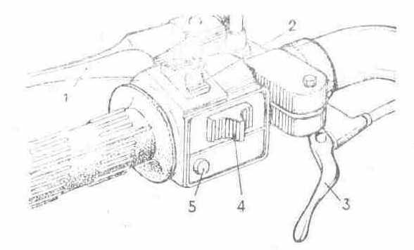
Fig. 4. Controls on a control surface at the left:
1 - clutch lever; 2 - switch of light of a head lamp; 3 - lever of a decompressor; 4 - switch of turn indicators; 5 - disconnecting switch of a sound signal

Throttle lever of the carburettor.
The throttle lever of the carburettor (handle of gas) is arranged on a control surface on the right. At turn of the handle by itself revolutions of a crankshaft of the engine are augmented, from itself - are reduced.
The switch combined.
The switch combined has: the switch of a mode of lighting with three fixed rule: dextral - is switched off, mean - the clearance lights are included, left-hand - are included main light of a head lamp and clearance lights; an emergency shut-down of the engine with two locked positions: lower - operational mode, upper - the ignition is switched off, the switch of the signalling system by distant light of a head lamp 5 - actuates light of a head lamp at clicking the push button irrespective of a rule of the switch of a mode of lighting.

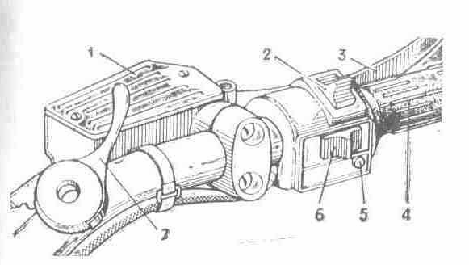
Fig. 5. Controls on a control surface on the right:
1 - barrel of the main brake; 2 - emergency shut-down of the engine; 3 - lever of the brake of a forward sprocket; 4 - handle of the throttle of the carburettor; 5 - switch of the signalling system by distant light of a head lamp; 6 - switch of a mode of lighting; 7 - lever of a fuel corrector

The notations of characters indicated on switches, are adduced in a fig. 6.
Shield of devices.
Shield of devices 1 (fig. 7). In a nem the indicating lights are located a speedometer. The speedometer has a speed indicator and two countable units: the meter of general run and meter of a daily run. For the installation of the meter of a daily run in initial (on "0") rule to turn the handle on shield of devices to the left, as is indicated by a finger.
On your motorcycle the red lamp IGNITION is not connected. She is intended for the control of ignition switch - on and activity of a generating set on motorcycles with a battery contact system of ignition and generator with electromagnetic excitation.

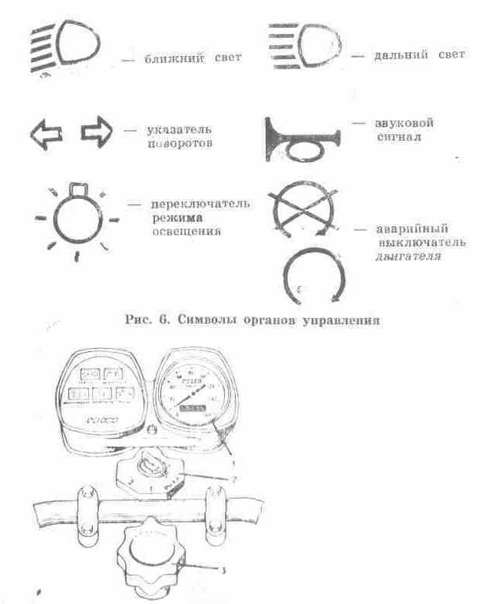
Fig. 6. Characters of controls

Fig. 7. Shield of devices:
1 - shield of devices; 2 - ignition switch; 3 - handle of the control damper

ATTENTION! The switch of the signalling system and switch combined are captured on a control surface by plastic pins, the rule is not subject to their regulation.
Green lamp a neutral POSITION.
Green lamp a neutral POSITION - lamp of the control of actuation of a neutral rule between I and II by transmissions in a gear box.
Green lamp TURN.
Green lamp TURN with fingers - lamp of the control of a system of turn indicators. At actuation of lanterns of turn indicators by the switch the lamp should flash in phase opposition with lamps of lanterns. At burnout of one of lamps in lanterns of the indexes of turn the frequency of flashing is augmented approximately twice. The lamp at actuation burns permanently is testify to short circuit in lanterns or fault of the interrupter of turn indicators.
Cyan lamp D. LIGHT.
Cyan lamp D. LIGHT - the lamp indicates about actuation of distant light.
Red lamp OIL.
Red lamp OIL - lamp of the control of activity of a separate lubricating system of the engine. Should shine at live ignition and inoperative engine (if there is submission of oil shine does not owe).
Be close to signals of lamps, it will help correctly to exploit a motorcycle.
The handle of the control damper.
The handle of the control damper 3 (fig. 7) arranged above a control surface in mid-range. The damper of a friction type serves for damping oscillations of a forward sprocket and control surface.
Ignition switch.
Ignition switch 2 (the fig. 7) has following rules of a key:
OFF - all customers of a current are switched off;
1 - the circuits of ignition, lighting, signalling system, XOFF, lamp of a neutral position and control of activity of a separate lubricating system of the engine are included;
2 - the clearance lights (parking) are included.
On the panel of the disconnecting switch (fig. 8) there are plugs For hooking up of customers of the electric power according to the electrical circuit (see appendix 7).

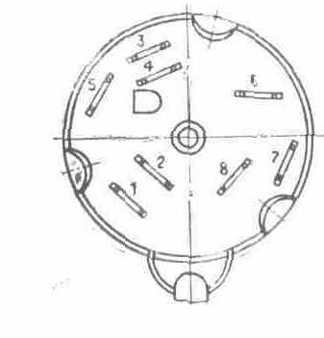
Fig. 8. ignition switches

It is recommended at exploitation of a motorcycle to keep track of by a condition of apposition of wires to terminals, not enabling their oxidation. In the autumn-winter season in a recessed square to fill up 3... 5 drips of a braking liquid.

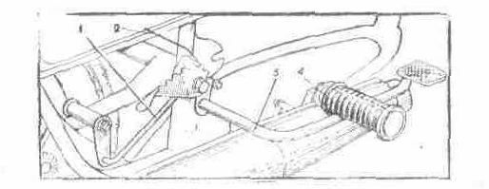
Fig. 9. The installation of the lever of the brake of a back sprocket:
1 - thrust of the brake; 2 - thrust of the switch of XOFF; 3 - lever of the brake of a back sprocket; 4 - cylinder of a step of the driver

The lever of the brake of a back sprocket.
The lever of the brake of a back sprocket (fig. 9) is arranged on the dextral party of a motorcycle. By clicking the lever actuate the brake of a back sprocket, thus the lamp of XOFF in a rear canopy of a motorcycle light up.
The lever of a releaser.
The lever of a releaser 17 (fig. 11) is arranged on a left-hand side of the engine, the launch of the engine makes by clicking the lever by a leg.
Change-over lever of transmissions.
The change-over lever of transmissions 18 (fig. 11) arranged on a left-hand side of the engine. The neutral position is between I and II by transmissions. The actuation I of transmission from a neutral rule is made by clicking a pedal of the lever downwards.

5. MAINTENANCE

5.1. Engine
The scheme of the engine with a gear box in a sectional view is given on an appendix 7.
The outside surface of the engine should be always clean. The mud on the barrel and its head degrades cooling of the engine, and the availability on a casing of oil and gasoline can be the reason ignitions of a motorcycle. The application of the marks, not advised by a manual of gasoline and oil conducts to anticipatory wearing of parts of the engine and to fast carbon deposition in the barrel, head, on the cylinder piston and suppository, that invokes an overheating of the engine, degrades its launch.
To a feed of the engine to apply gasoline and oils according to tab. 2.

5.1.1. Brief indicatings on removal of the engine
Removal of the engine to make in the following order:
- to remove a saddle, guardss and petrol tank;
- to remove arcs of safety;
- to disconnect a tail pipe;
- to disconnect a rope of a decompressor, rope of a metering device from the distributive coupling, a rope of coupling and to remove a tip Ignition plug;
- to disconnect an air cleaner;
- to remove the carburettor;
- to disconnect of an electrical wire of the sensor of ignition and generator from a rectifier - voltage regulator, switchboard, main bundle, wire from a contact a neutral POSITION on a casing under air filter and valve - sensor;
- to disconnect from the engine jackets of a circuit;
- to remove a dextral cover of a casing to separate a circuit;
- to ease nuts of attachment of the engine in an afterpiece;
- to turn away nuts of bolts of attachment of the engine to get bolts in a forward attachment point of the engine;
- to remove forward mounting brackets of the engine;
- to remove the engine from the cradle in a left-hand side, submitting it forward - hill up.
To establish the engine in return sequence.

5.1.2. Coupling
The service of coupling is encompass byed to regulation of the gear cutoffs of coupling, which one consists of a cylinder with an eccentric and lever cutoffs of coupling, thruster with a cap, adjusting screws on the compression disk and clutch lever on a control surface, rope of coupling, restoring spring.
Regulation of coupling to make in the following order:
- to remove a cover of the hatch in the left-hand cover of a casing;
- to ease a lock nut of an adjusting screw on a control surface to wrap up a screw against the stop;
- to ease a lock nut of an adjusting screw on the compression disk of coupling to turn out an adjusting screw on 1... 2 revolutions;
- wrenching an adjusting screw on a control surface to establish the lever cutoffs coupling arranged on a dextral cover so that a ledge on the lever has coincided with a mark on a cover;
- an adjusting screw on the compression disk of coupling to wrap up against the stop (not hardly) to ease it on 1/4... 1/2 revolutions and to fix by a lock nut;
- free running of the end of a clutch lever on a control surface to establish with the help of an adjusting screw, which one to fix by a lock nut.
Disassembly and assembly of a clutch to make without removal of the engine from the cradle in the following order:
- to drain oil from a gear box, having turned away a locking bolt in bottom of a casing;

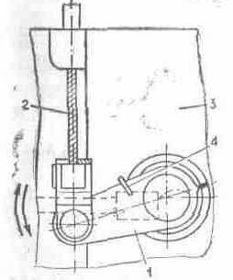
Fig. 10. Regulation of coupling:
1 - lever cutoffs of coupling; 2 - rope of coupling; 3 - dextral cover; 4 - restoring spring

- to remove guardss to disconnect an oil line from an inlet pipe of the barrel;
- to disconnect an electrical wire of the valve - sensor from the left-hand cover of a casing and rope of a metering device from the distributive coupling;
- to remove a change-over lever of transmissions, lever of a releaser and left-hand cover of a casing, thus to monitor, that the pipe connection of the drive of an oil pump has not dropped out;
- to turn away nuts of springs of coupling to remove springs with caps;
- to remove the compression disk and disks of coupling;
- to turn away a nut on the primary arbor (thread left-hand), for what it is necessary to include I transmission and to stop a back sprocket or to stop an internal barrel of coupling, to remove an internal barrel of coupling;
- to bend off a lock washer and, turning away a bolt of attachment of a sprocket of a crankshaft to remove simultaneously sprocket together with an outside barrel of coupling and circuit.
At knocking a circuit on idle speed or large sag (more than 15 mms) circuit to exchange.
Assembly to make in return sequence, having paid attention on following:
- maiden to establish the reference disk by depth of 3 mms by a lock ring groove in the party of a gear box;
- disks to collect with allowance for alternations steel and plastic;
- by an even tightening of nuts to shrink springs so that butt ends of nuts were above than butt ends of caps on 3... 4 mms, and the compression disk at cutoffs of the lever of coupling was displaced without a skew;
- to fix and to stop by a spacer a sprocket of a crankshaft (sprocket and outside barrel of coupling with a circuit establish simultaneously);
- to mate a trailing-edge of an oil pump with a groove of the coupling located in the head of a bolt of attachment of a sprocket;
- to establish the left-hand cover of a casing;
- at the installation of guardss to mate a protecting tube of an oil line and wire of the valve - sensor (above a handset) with a cut-out in bottom of a protective casing, in order to prevent their pinch.

5.1.3. Gear box
The service of a gear box consists in regular stock-taking of oil in a box and its well-timed replacement. The level of oil should be within the limits of a handhole.
Replacement of oil to make on hot the engine, it is best at once after trip. To drain used oil through a foramen in bottom of a casing (fig. 11). To wrap up a fuse, to slosh 0,5 l of oil through a foramen under a cover of the hatch and to give to the engine to study 1... 2 min. After that oil to drain and to slosh 1 l of fresh oil (see tab. 2).
Gear box four-stage (fig. 12)
The disassembly and assembly of a gear box can be made without removal of the engine from the cradle. Disassembly:
- to drain oil from a gear box;
- to remove a silencer;
- to remove a dextral cover of a casing with a rope;
- to take out a rod of coupling from a rubber cap to separate a circuit;
- to turn away eight screws and to remove a cover of a gear box;
- to remove quadrant of a gear-shifting.
All parts of a gear box (except for the primary arbor and cylinders of forks of transmissions) can be taken out from a casing.

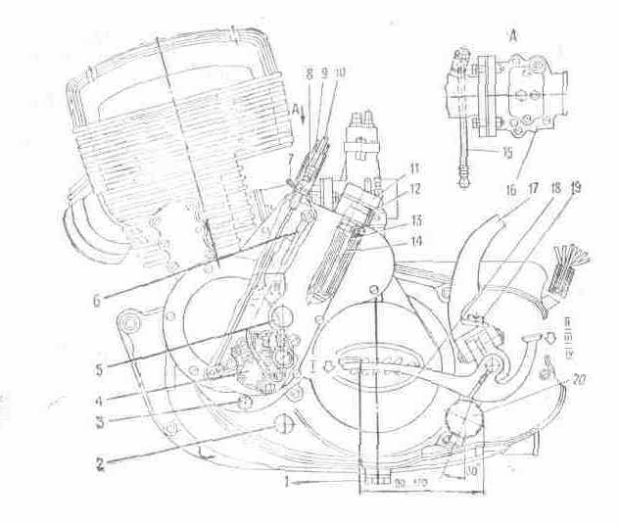
Fig. 11. The engine (left-side view):
1 - fuse of a drain of oil from a casing; 2 - handhole of a gear box; 3 - fuse of a drain of oil from capacitance of a lubricating system of the engine; 4 - oil pump; 5 - handhole of capacitance of a lubricating system of the engine; 6 - electrical wire of the valve - sensor; 7 - paper clip; 8 - screw adjusting; 9 - cap; 10 - rope of a metering device; 11 - fuse of a bulk foramen of capacitance of a lubricating system of the engine; 12 - ring strong; 13 - filter; 14 - body of the filter; 15 - oil line of an inlet pipe; 16 - carburettor; 17 - lever of a releaser; 18 - change-over lever of transmissions; 19 - fuse of a bulk foramen of a crankcase; 20 - step of the driver

For removal of the primary arbor and cylinders of forks of a gear-shifting to disassemble coupling to remove barrels. To turn unscrew screws, to remove a locking plate. To pay attention to arrangement of adjusting spacers on intermediate, primary arbors, arbor of a gear-shifting, that at assembly to put them on a place.

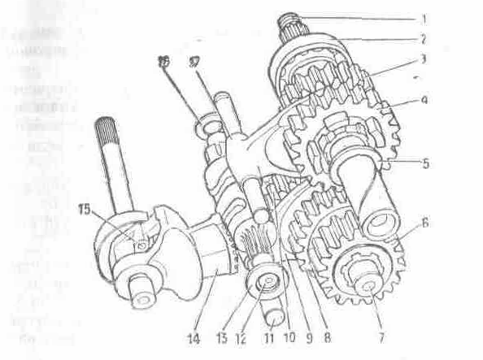
Fig. 12. A gear box:
1 - primary arbor; 2 - ball-bearing 204; 3 - cone II of transmission; 4 - cone II and IV of transmissions; 5 - persistent spacer; 6 - cone of a jackshaft; 7 - jackshaft; 8 - cone III of transmission; 9 - fork of switching I and III of transmissions; 10 - cone I and III of transmissions; 11 - cylinder of a shirt control fork; 12 - arbor of a gear-shifting; 13 - persistent spacer; 14 - quadrant of a gear-shifting; 15 - speed-control mechanism; 16 - adjusting spacers.17 - fork of switching II and IV of transmissions.

Assembly:
- to collect with all cones a jackshaft and to put it on a place;
- to collect all cones on the primary arbor with all adjusting and persistent spacers. If the arbor taken out, to put it on a place;
- to establish shirt control forks;
- to establish on a place the arbor of a gear-shifting (to not overlook dress on the pasted end adjusting spacers), removing the clamper in the party;
- tenons of forks to enter into flutes of the arbor of a gear-shifting, in foramens of forks to establish cylinders of forks of a gear-shifting and to fix by a locking plate;
- to establish the arbor of the gear of switching, if he is removed;
- to get quadrant of a gear-shifting in engagement with the arbor of a gear-shifting. The label on dens of quadrant should coincide with neat for a cavity dents of the arbor of a gear-shifting;
- to establish persistent spacers on the end of the arbor of a gear-shifting and primary arbor to put the gasket, cover of a gear box, to postpone the stall screws. At the installation of a cover of a gear box the mild impacts on her by a hammer are enabled. The moving secondary vale on an axis should be 0,4... 0,6 mms.

5.1.4. Disassembly and assembly of the engine
For disassembly of the engine to make operations described in sections "Coupling", "Gear box", "Generator", then:
- to remove the head of the barrel, barrel to take out lock rings, pin, to shine the cylinder piston;
- to turn out from the dextral party screws of attachment of halves of casing to beat out on 1/2 lengths monitoring bushes and to separate halves of casing;
- to shine by mild impacts of a wood hammer on a plane of the connector the left-hand half of casing from an axel of a crankshaft;
- to remove from an axel a dextral half of casing;
- to take out from a foramen under bearing boxes the lock ring and pressing the ball-bearing;
- to take out the second lock ring, strut sleeve;
- extrude from the left-hand half of casing by a special tube expander the gland and outside yoke cone bearing is simultaneous;
- to remove from a dextral half of casing a gland and outside yoke cone bearing.
After replacement or inspection of a crankshaft, glands assembly of the engine to make in return sequence. Thus it is necessary to pay attention on following:
- to not enable confusing yokes cone bearing;
- to not enable damages and skews of gaskets;
- to eliminate the carefully aged faded varnish (paint) from planes of the connector of a casing;
- to flush all parts in gasoline or in kerosene.
For facilitation of dismantling and mounting of bearing boxs, glands and piston pin it is recommended halves of casing and cylinder piston to heat up to 70... 90 С. Assembly to make in return sequence:
- to establish in the left-hand half of casing the internal lock ring, strut sleeve, extrude a gland by an outstanding working edge in the party of a strut sleeve to establish oil-routing a spacer, extrude an outside yoke cone bearing, to paste a crankshaft, not enabling a bend of a working edge of a gland;
- extrude an outside yoke cone bearing in a dextral half of casing;
- to plot on a plane of the connector of halves of casing bakelite varnish LBS-3 a GOST 901-78 or glue BF-2 a GOST 12172-74 or enamel of Nitrocellulose - 273 the aluminium technical specifications 6-10-895-82 or petrol-resistent potting compound;
- to connect halves of casing by bushes and to postpone the stall screws.
To establish one lock ring of a piston pin in a flute of the cylinder piston piston pin, lubricated with engine oil, to paste into a foramen of a boss of the cylinder piston, mount the cylinder piston on the head of a connecting rod, holding an arm the cylinder piston, mild impacts of a wood hammer to push the pin of the cylinder piston into a foramen of the head of a connecting rod against the stop in the lock ring and to paste the second lock ring.
To establish the gasket on a flange of a casing, to put on the gasket the wood fork or two bars, to establish on them the cylinder piston, to establish joints of piston rings against, locking pins, to shrink rings by a metallical belt, to lubricate a cylinder liner with motor oil and is cautious mount the barrel on the cylinder piston, is removed the fork from under the cylinder piston, to establish the barrel on a casing and to fix by nuts.

5.1.5. System of measured lubrication of the engine
The lubricating system of the engine provides lubrication of parts chancraft of the gear and barrel-cylinder piston of group of the engine and consists of oily capacitance 8 (fig. 13) in the left-hand cover of a casing 3, screw oil pump 2, presented in rotation from a crankshaft through a pipe connection 1 metering device 7, oil pump, arranged in a body, and metering device, controlled by a rope, 13, interlocked with a rope throttles of the carburettor 15, piston valve of the sensor 5 and diaphragm reverse valves 9, arranged in a body of an oil pump, oil lines 21 and 24, electrical wire 11 and caution light 12 "Oils" arranged in shield of devices.
At chargings the gasoline recommends to check up availability of oil in oily capacitance on a handhole 6, arranged in a cover of oily capacitance.
The volume of oil is lower than a level of a handhole (0,3 л) provides run 150... 200 kms. The indicated volume is stand-by.
Before the beginning of exploitation of a motorcycle, in case of absence of oil in a transparent oil line, it is necessary:
- to slosh oil in oily capacitance (see tab. 2);
- to slosh in the petrol tank 1... 1.5 l of a mix of oil with gasoline in a proportion 1:100;
- to let the engine (see section "Launch of the engine");
- to shift a cap 9 (fig. 11) with a paper clip 7 to prolate for a shell a rope of a metering device 10 against the stop and, support engine run idling, to fill in a transparent oil line with oil (time indispensable for pomp of a lubrication system, 2... 3 mines);
- to establish a shell of a rope of a metering device and cap with a paper clip to refuel the petrol tank by clean gasoline.
At filling of an oil line on the earlier working engine is enabled to make accelerated filling of a transparent oil line at availability in the petrol tank of clean gasoline.
Before the beginning of motion after long-lived parking of a motorcycle at the temperature of below minus 25 С (the cold engine) is necessary to warm up oil in oily capacitance by a running engine on a mode of idling speed during 2... 3 min. In case of usage of oils MC-14, MC-20 and MGD-14M it is necessary to dilute oil in oily capacitance by gasoline (5 % to a volume of oil).

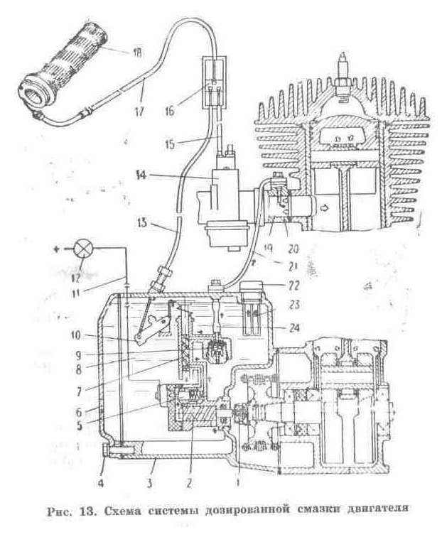
Fig. 13. The scheme of a system of measured lubrication of the engine:
1 - coupling; 2 - oil pump; 3 - left-hand cover of a casing; 4- fuses of a drain of oil from capacitance; 5 - valve - sensor; 6 - handhole; 7 - metering device; 8 - oily capacitance; 9 - reverse valve; 10 - control lever; 11 - electrical wire; 12 - caution light; 13 - rope of a metering device; 14 - carburettor; 15 - rope of the throttle of the carburettor; 16 - distributive coupling; 17 - rope of gas; 18 - handle of the throttle of the carburettor; 19 - injector; 20 - inlet pipe; 21, 24 - oil line; 22 - fuse; 23 - filter

At temperatures below minus 15 С can descend delay of actuation (ignition) of a caution light OIL after a shutdown up to 10 min.
The design of an oil pump does not demand its regulation in run up to 50000 kms. Diagnostic and regulation of an oil pump are possible only on special benches. It is forbidden to upset enamel cover of screws on a control lever of an oil pump and on a reverse valve.
In case of impossibility to eliminate fault in a system of measured lubrication it is necessary to proceed to lubrication by a mix of oil with gasoline in proportions according to tab. 2, having disconnected the pompe from a crankshaft and having removed the coupling 1 (fig. 13).
Regulation of free running of a rope of a metering device
Regulation of free running to conduct in the following order:
- to ease a paper clip 7 (fig. 11) and to shift a cap 9 hill up on a shell of a rope;
- to turn unscrew a lock nut and to screw on some revolutions a screw, for creation of free running of a shell of a rope of a metering device;

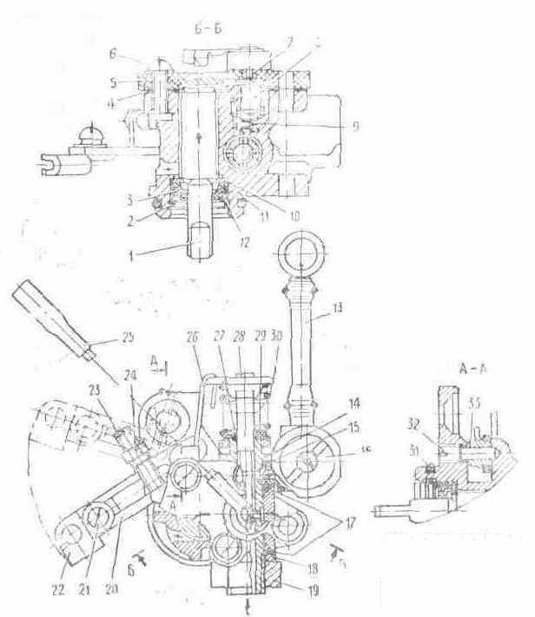
Fig. 14. A lube pump:
1 - feeding screw; 2 - lock ring; 3 - sealing ring; 4 - gasket; 5 - cover; 6 - screw; 7 - terminal (saddle); 8 - cylinder piston; 9 - spring; 10 - spacer; 11 - casing of pump; 12 - spacer; 13 - oil line; 14 - sleeve of a metering device; 15 - gasket; 16 - reverse valve; 17 - O-ring; 18 - spacer; 19 - nut; 20 - control lever; 21 - screw; 22 - rod; 23 - adjusting screw; 24 - lock nut; 25 - electrical wire; 26 - thrust; 27 - O-ring; 28 - rod of a metering device; 29 - cap; 30 - spring; 31 - O-ring; 32 - axis; 33 - bush

- to make (if necessary) regulation of free running of the handle of the throttle of the carburettor (see section "Carburettor");
- to turn the handle of the throttle of the carburettor on value of free running and at this rule of the handle to eliminate free running of a shell of a rope of a metering device by wrench of a screw;
- to fix a screw by a lock nut and to establish a cap with a paper clip.

5.1.6. Brief indicatings on replacement of parts of piston group
The barrel on a minor diameter of the sleeve has four dimensional groups, according to which one produce cylinder pistons. New the barrel and cylinder piston select from identical groups till tab. 3. At replacement of the cylinder piston the installation it from following group (greater diameter) is enabled. The oval - barrel-type cylinder piston without rings should be displaced in the barrel under dead weight, split-skirt piston and rings - with an effort 3... 8 kgs.
The table 3
Marking of group diameter, mm | Barrel | the cylinder piston
 | Barrel | With a split skirt | Oval - barrel-type
1 | 71,99^{+0.01} | 71,94_{-0,01} | 71,98_{-0.01}
0 | 72,00^{+0.01} | 71,95_{-0,01} | 71,99_{-0,01}
00 | 72,01^{+0,01} | 71,96_{-0,01} | 72,00_{-0,01}
000 | 72,02^{+0,01} | 71,97_{-0,01} | 72,01_{-0,01}
The marking of group is indicated on a flange of the barrel and head of the cylinder piston.
The cylinder piston and pin will be labeled by identical paint (green, white and black), which one is put on butt end of the pin and boss of the cylinder piston. At repair of piston group it is necessary to be guided by tab. 3, 4, 5.
The table 4
Number of repair | marking | diameter, mm
Number of repair | marking | Barrel | the cylinder piston | piston rings
1-st | IP | 72,5^{+0,02} | 72,46_{-0,03} | 72,5^{+0,03}
2 | 2Р | 73,0^{+0,02} | 72,96_{-0,03} | 73,0_{+0,03}
The table 5
Number of repair | marking | diameter of the pin, mm
1-st | red paint on the one hand | 15,1_{-0,005}
2 | red paint from two parties | 15,2_{-0,05}
At the installation of repair pins of a foramen in bosses of the cylinder piston to finish up to the size ensuring a backlash 0... 0,005 mms, for the upper head of a connecting rod - 0,01... 0,03 mms.
At replacement of piston rings it is necessary to establish rings in the barrel and to test interface gap of rings, he should be 0,25... 0,45 mms, if a backlash less than 0,25 mms, joints of rings grind.

5.2. The power supply system also issue

5.2.1. Petrol crane
Petrol crane is joint with a sump and screen filters. The pen arm бензокраника has three positions (as directed on a body):
- petrol crane is open,
- petrol crane is closed,
- usage of a reserve of fuel In a reserve of 0,75 l of gasoline approximately on 20 kms of a route of a motorcycle.
For clearing of a sump to bar petrol crane to turn away a sump and to flush parts in gasoline.

5.2.2. Carburettor
The scheme of the carburettor is rotined in a fig. 15.
On-stream of motorcycle it is necessary to check up and to regulate engine run at minimum rotational speed of a crankshaft on a throwaway course, complianting of the engine to a control handle by the throttle.
The frequency control of rotation geniculate has gorged idling has large value, as the system of idle acts as on small, and on a flooring motor loads. The fuel content given a system of idle, on a mode of full discovering of the throttle makes 5-10 % about, and on a mode of partial discovering of the throttle - 10-15 % from total of fuel consumed by the engine.
Rpm control of a crankshaft idling to make in the following order:
- before launch of the engine it is desirable by an adjusting screw 14 (fig. 15) to establish the throttle 9 in such position, that between its edge and wall of the chamber 6 there was a backlash 1,5... 2,0 mms. The backlash is established at the removed carburettor. Before the installation of a backlash it is necessary to convince, that the throttle 9 is freely displaced and under operating of a spring 10 completely overlaps the mixing chamber 6;
- to wrap up an adjusting screw 18 completely, and then to turn out half way revolution;
- to let the engine to warm up it and to establish minimum steady revolutions by a screw 14;
- slowly to wrench a screw 18, the rotational speed of a crankshaft will increase in the beginning, and then to reduce. The moment of a top-of-descent of rotational speed of a crankshaft indicates an optimum position of an adjusting screw 18 for the given position of the throttle;
- screwing a screw 14, again to lower rotational speed of a crankshaft and for a new position of the throttle to find by the mentioned above way an optimum position of a screw 18.
If the rotational speed of a crankshaft is great, this operation to repeat until the minimum, steady rotational speed of a crankshaft will be obtained.
Regularity of selected regulation idling to check up by sharp discovering and closing of the throttle. If the engine at sharp discovering of the throttle off or badly gains rotational speed, the mix is necessary slightly обогатить by minor turning home of a screw 18. If it is necessary to impoverish the engine глохнет at sharp closing of the throttle, a mix open of a screw.
At exploitation of a motorcycle in different road and meteorological conditions it is necessary to concentrate or to lean a mix by a repositioning of a dosing needle 19 in the throttle 9. At lowering of a needle the mix leans, at raising - is concentrated. Mixture leaning to make at exploitation of a motorcycle at the altitude from 2000 m and more above sea level, and also in separate cases in process of wearings of the sprayer 3: At temperature the minus 15 С a needle is lower to raise on one - two divisions.
Regularity of selected regulation of the carburettor to check up on colour of isolator and central welding rod ignition plug:
- black colour of a burn - rich mixture;
- light yellow, sand or albescent - poor mixture;
- brown or bricky - normal mix.
At negative temperatures after launch of the engine up to its full warm-up use a fuel corrector, which one at turn of the lever up to 50 % from a general course provides indispensable mixture enrichment. At further turn of the lever the fuel corrector works as a launching device.
The service of the carburettor consists in periodic clearing both washdown of its parts and channels from mud and gum residues. To flush parts and channels by clean gasoline, and if there is copious tarry deposits - solvent for nitropaints. The washed out parts and channels to blow out by a spray of compressed air. To not clean metering jets and foramens of the carburettor by a strand and other metallical subjects.
At exploitation of a motorcycle to keep track of by a condition of the carburettor. Having found out even minor drip of fuel to tighten fasteners. The constant drip of fuel through a drain hole 27 testifies to a leakage of a stop needle of a fuel injection valve 24, float 25 or heightened level of fuel in the float chamber. For elimination of drip of fuel to flush the float chamber, delivering fuel a channel to test a condition of an elastic spacer on the valve, air-tightness of a float 25, to adjust a level of fuel, turning in a bracket of attachment of a stop needle 28.
The level of fuel in the float chamber determines (at a removed cover) position of a plane of a symmetry of a float apart 13+-1,5 mms from a plane of the installation of a cover of the float chamber. Thus the carburettor to arrange by a float hill up.
The regulation of free running of a rope of the throttle 13 carburettors (fig. 15) is made guide of a rope 12 in the following order:
- to shift a rubber protective jacket 35 on a shell of a rope to turn unscrew a lock nut of guide and, turn or turning away routing, to establish free moving of a shell within the limits of 1... 2 mms;
- to wrap up a lock nut and dress a jacket on routing of a rope;
- to test free running of a rope of a metering device of the pompe;

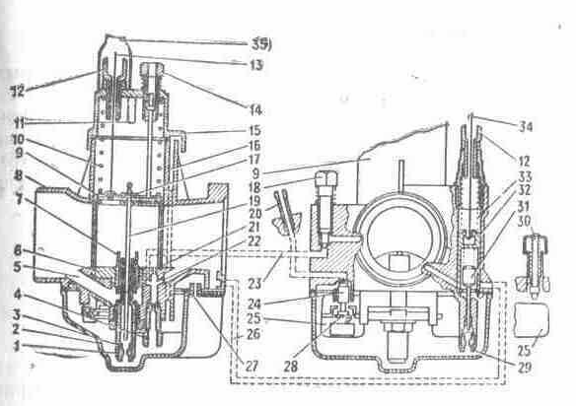
Fig. 15. The scheme of the carburettor:
1 - metering jet of a fuel main system; 2 - cover of the float chamber; 3 - sprayer of a main system; 4 - metering jet of fuel idle; 5 - air passage of a main system; 6 - mixing chamber; 7 - body of the sprayer of a main system; 8 - carburettor body; 9 - throttle; 10 - spring of the throttle; 11 - emphasis - terminator of rise of the throttle; 12 - guide of a rope; 13 - rope of the throttle; 14 - adjusting screw of rise of the throttle; 15 - cover of the carburettor; 16 - balance channel of the float chamber; 17 - lock of a needle; 18 - screw of adjusting idle; 19 - dosing a needle; 20 - delivering fuel the union; 21 - foramen transient systems of idle; 22 - emulsion channel of a system of idle; 23 - air passage of a system of idle; 24 - stop needle of a fuel injection valve; 25 - float; 26 - emulsion channel of a launching device; 27 - drain hole; 28 - mounting bracket of a stop needle; 29 - fuel metering jet of a corrector; 30 - button of a float; 31 - needle dosing launching devices; 32 - plunger of a launching device; 33 - spring of a plunger; 34 - control cable by a corrector: 35 - jacket protective

5.2.3. Inhaler
Depending on a dust content of roads, on which one the motorcycle is exploited, in batches to change oil (see tab. 2) and to flush a filter pack by gasoline. Oil to fill up in the collected air cleaner through mouth, having removed air scooping(fig. 16). In order to prevent a skew at assembly of an air cleaner a tightening of screws to make uniformly.

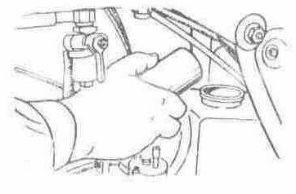
Fig. 16. A filling up of oil in an air cleaner

5.2.4. Silencer
On a motorcycle the dismountable silencer of exhaust gases is established. For removal of a silencer to turn away(unscrew) nuts of attachment of a flange of a receiver pipe to a fitting pipe of the barrel to turn unscrew a nut of attachment of a body to the cradle. For deleting a burn from an acoustic tube 2 (fig. 17) and cover to turn unscrew screws 3 attachments of a cover to remove a cover, to take out an acoustic tube and to furbish parts.
At the installation of a silencer previously to fix a silencer to the cradle to establish a receiver pipe and to postpone the stall all nuts.

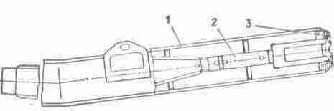
Fig. 17. A silencer:
1 - body; 2 - acoustic tube; 3 screws.

5.3. Undercarriage

5.3.1. Suspension of a forward sprocket with the disk brake
On a motorcycle the suspension of a telescopic type with a spring-hydraulic shock-absorber and air control is established.
The shock-absorber is filled with oil in quantity according to tab. 2. Quantity of oil in a shock-absorber essentially influences performance curves of a shock-absorber. At an exuberant volume of oil pressure in a cavity of the rack sharply increases, that can result in mortality of a gland.
The design of a shock-absorber envisions air control of rigidity depending on road conditions and load. The rollin of air in a shock-absorber is made by the pompe affixed to a motorcycle. For this purpose to establish a motorcycle on a central support, having supplied the hung out condition of a forward sprocket to increase displacement volume of a shock-absorber, to remove a rubber cover and cap in a top of a shock-absorber and through the valve of a reversing valve to make rollin. A recommended maximal pressure in a shock-absorber 0,04 MPa (0,4 kgs/sm2) to keep track of by , that the difference of pressure in shock-absorbers did not exceed 0,01 MPa (0,1 kgs/sm2).

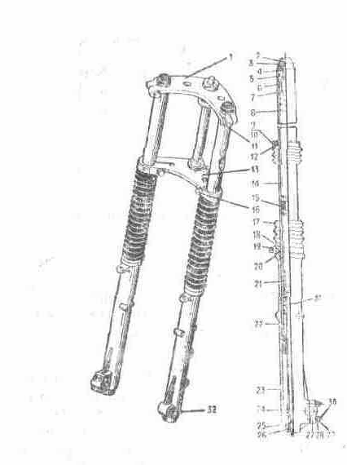
Fig. 18. The suspension of a forward sprocket with the disk brake:
1 - bridge upper; 2 - valve of a reversing valve; 3 - cover; 4 - ring strong; 5 - ring strong; 6 - nut; 7 - cup upper; 8 - spring; 9 - screw; 10 - nut; 11 - bolt; 12 - clamp upper; 13 - bridge lower; 14 - barrel the worker; 15 - bush; 16 - bolt; 17 - jacket; 18 - ring lock; 19 - clamp lower; 20 - sealing ring; 21 - spring; 22 - cylinder piston with a piston ring; 23 - barrel of the tank; 24 - tip; 25 - spacer strong; 26 - screw; 27 - holder of an axis; 28 - spacer; 29 - nut; 30 - bolt; 31 - spring of an all-clear signal; 32 - screw

The maintenance behind shock-absorbers is reduced to the control behind availability of oil in racks and sustaining objection of air pressure.
Before disassembly of shock-absorbers to eliminate air from the upper cavity of a shock-absorber by clicking the valve of a reversing valve; to remove a sprocket and shield (see section "Removal of a forward sprocket"), to ease through bolts in the lower and upper bridges and clamps of attachment of rubber jackets 17 to a lower bridge through the wood gasket by mild impacts of a hammer on a nut 6 to beat out the barrel 14 of bridges, to turn out a nut 6 of the barrel, to drain oil. To flush a shock-absorber by clean gasoline. To slosh oil.
Further disassembly of a shock-absorber to conduct in the following order:
To remove rubber jackets, having eased clamps of attachment them to barrels of the tank, and to take out both springs 8. To paste a steel band by the sizes 450X17X2,5 mm into a spline at butt end of the cylinder piston 22 or bar of length 450 mms a dia of 18 mms with a tumulus 10-150 and length 10 mms on the end in a foramen of the cylinder piston and, retaining it, to turn out a screw 26. To take out the barrel 14 of the barrel of the tank 23, to flush parts. A screw 26 to establish with application of a potting compound "Anaterm" or other oilproof potting compound, retaining the cylinder piston from turn.
Assembly to run in of return sequence to slosh oil.
At replacement of oil(butter) without disassembly of shock-absorbers, oil to drain through a foramen in bottoms closed by a screw 32.

5.3.2. Suspension of a forward sprocket with the two-jaw brake
To disassemble the telescopic fork in the following order: to remove a sprocket and shield, half lengths of a thread to turn unscrew a fuse 3 and body of a gland .13, to ease through bolts in the lower and upper bridges. Through the wood gasket by mild impacts of a hammer on a fuse 3 to beat out carrier a handset 12 of a upper bridge 4 to turn out a fuse 3 of carrier of a tube 12 and from a rod 16, to take out pen of the fork, to drain oil, to turn out a bolt 23, to get a shock-absorber together with a spring, to turn unscrew a body 13 glands and to remove a sliding tube 21. To flush parts.

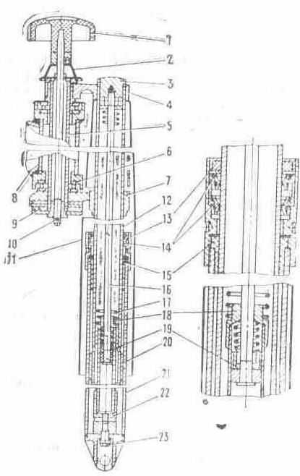
Fig. 19. The suspension of a forward sprocket with the two-jaw brake:
l - handle of the damper; 2 - spring; 3 - fuse: 4 - bridge upper; 5 - cylinder of a control pillar; 6 - ball-bearing; 7 - bridge lower; 8 - cradle of a motorcycle; 9 - disk of the damper; 10 - cotter pin; 11 - casing; 12 - tube of carrier; 13 - body of a gland; 14 - gland; 15 - bush of a sliding tube; 16 - rod; 17 - spring; 18 - tip of a hydraulic shock absorber; 19 - valve of a rod; 20 - cylinder piston of carrier of a tube; 21 - tube sliding; 22 - rack of a hydraulic shock absorber; 23 - bolt

Assembly to make in return sequence, having paid attention, that the pin on the rack 22 was mated with a fixing foramen in a tip of a sliding tube of the fork after that to wrap up a bolt 23 before failure.
At assembly in each pen of the fork through a threaded foramen under a fuse 3 to slosh 0,175 l of oil (see tab. 2).
In the rack of a shock-absorber there is a spring of an all-clear signal, which one in combination to a hydraulic system enriches the characteristic of the suspension.

5.3.3. Control pillar
For elimination of an axial clearance of a control pillar to ease through bolts in a upper bridge to remove the handle of the damper, to bend off a lock washer, to ease a nut of a upper bridge, to wrap up an adjusting nut against the stop, then to ease it on 1/8... 1/6 revolutions to wrap up a nut of a upper bridge and to turn in a lock washer.
The lubrication (see tab. 2) is applied to bearing boxs of a control pillar.

5.3.4. Suspension of a back sprocket
The suspension of a back sprocket consists of the pendulous fork and two пружинно-hydraulic shock absorber. The axis of the pendulous fork is established in bearing boxs of rolling. The service of the pendulous fork is encompass byed to stock-taking of lubrication in bearing boxs and iterating it if necessary. Lubrication till tab. 2.
Shock-absorber of the suspension of a back sprocket (the fig. 20) has regulation of contraction of a spring on three positions depending on load on a back sprocket. At increase of load to turn by a key the regulator clockwise. For replacement of oil to remove a shock-absorber to squeeze a spring 6 suspensions up to an output of reference semirings 1, to remove a spring 6, sleeve 2, to turn unscrew a body of a gland 3, to take out a rod 4 and barrel 8 and to drain oil. To flush parts. Assembly to make in return sequence. At assembly to slosh 0,075 l of oil (see tab. 2).
The shock-absorber has a spring of an all-clear signal, which one in combination to a hydraulic system enriches the characteristic of the suspension.

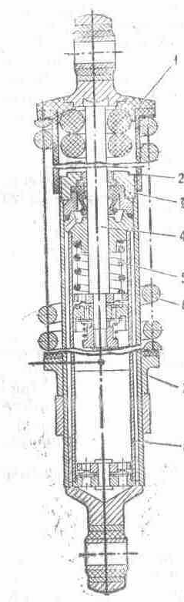
Fig. 20. A shock-absorber of the suspension of a back sprocket:
1 - reference semi ring; 2 - sleeve; 3 - body of a gland; 4 - rod; 5 - spring of an all-clear signal; 6 - spring; 7 - regulator; 8 - barrel

5.3.5. Saddle with shield
For removal of a saddle to click the thruster 1 (fig. 21) detent 2 to uplift a forefront of a saddle and, submitting a saddle forward, to remove it from the cradle, to disconnect wires.

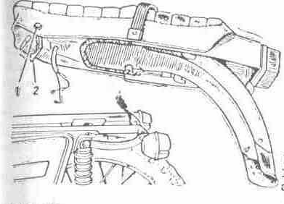
Fig. 21. Removal of a saddle:
1 - thruster; 2 - detent

5.3.6. Sprocket
Depending on a complete set on a motorcycle the forward and back sprockets unit-cast with trunks of the miscellaneous size and sprocket with spokes with trunks of one size, both interchangeable, and not interchangeable can be established.
Removal of a forward sprocket.
For removal of a forward sprocket with the disk brake (fig. 22) to ease nuts of attachment of an axis in the dextral rack of a shock-absorber, open and to turn unscrew a nut (thread left-hand) attachment of a wheel axle; to turn out screws of attachment of a casing of the disk brake; to raise hill up on a flexible roller a casing; to turn unscrew a bolt of attachment of a flexible roller, to take out a flexible roller from the drive, to remove a casing from a flexible roller, to take out an axis 5, to remove a sprocket from shock-absorbers of the suspension and grip of the brake by motion downwards and forward. ATTENTION. After removal of a sprocket to not depress the lever of a hand brake, as there can be an outflow of brake fluid and contact of brake shoes, it is required pomp of a brake assembly.

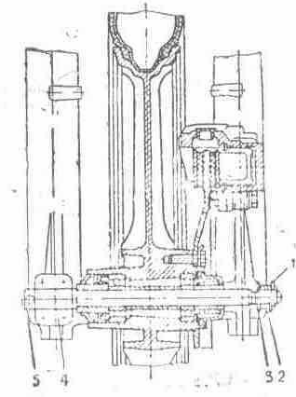
Fig. 22. Removal of a forward sprocket with the disk brake:
1 - cotter pin; 2 - nut; 3 - spacer; 4 - holder of an axis; 5 - axis

In a sprocket the bearing boxs with one protective spacer (semiclosed) are established. For lubrication of the bearing box to take out the bush with extrude by a flange and gland, if necessary выпрессовать the bearing box to flush it and to lubricate (see tab. 2).
The installation of a sprocket to conduct and return sequence.
Removal of a back sprocket.
For removal of a back sprocket to remove a saddle to turn unscrew a nut 2 (fig. 29) attachment of an axis (thread left-hand), to take out an axis and strut sleeve, to remove a sprocket from splines of a hub and from brake shoes, submitting it to the left, forward and hill up. At assembly a strut sleeve to establish to a small dia to a hub of a sprocket.
For lubrication of bearing boxs to turn unscrew a body seal to remove a decorative cover, extrude the left-hand bearing box through a foramen of the dextral bearing box, to take out a strut sleeve and lock ring, выпрессовать the dextral bearing box, to flush and to lubricate parts. It is necessary to fill in with lubrication a cavity between the bearing box and fixing spacer. The bearing box запрессовать by a protective spacer out.
The installation of a sprocket to make in return sequence.
Removal of a forward sprocket with the two-jaw brake it is drumtype.
For removal of a forward sprocket to disconnect a rope of the drive of the brake of a forward sprocket from the lever of the brake on a control surface, previously having squeezed the lever 1 (fig. 23) in the party indicated by a finger to turn unscrew a bolt 3 and to take out a flexible roller, to ease a through bolt of attachment of an axis in a tip of the left-hand sliding tube, to turn out an axis (thread left-hand) and to remove a sprocket from pens of the fork.
For lubrication of bearing boxs to turn unscrew a body seal to remove a decorative cover, выпрессовать the left-hand bearing box through a foramen of the dextral bearing box, to take out a strut sleeve and lock ring, extrude the dextral bearing box, to flush and to lubricate parts (necessarily to fill in with lubrication a cavity between the bearing box and fixing spacer). The bearing box extrude by a protective spacer out.

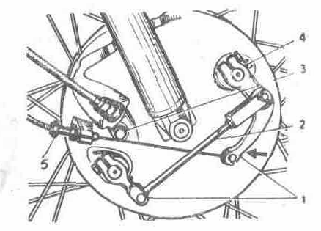
Fig. 23. Removal of a forward sprocket with the two-jaw brake:
1 - levers; 2 - thrust; 3 - bolt; 4 - check box; 5 - screw adjusting

The installation of a sprocket to conduct in return sequence.
Pulling of spokes of a sprocket.

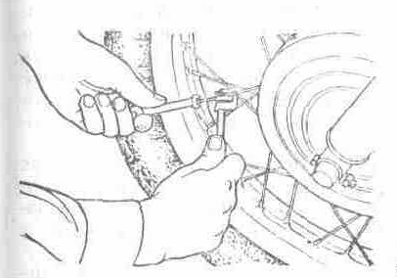
Fig. 24. Tension control of spokes

At exploitation of a motorcycle with sprocket with spokes by sprockets to keep track of by a tension of spokes, in a case is loosed uniformly to tighten them on all circumference of a hoop For an avoidance провертывания of a spoke at it bowse in to restrict a spoke by adaptation (fig. 24) for squeeze out of an axis of a chain link, under a screw which one to establish a special bearing from a complete set of the tool. Minor bowse in of spokes to make without removal of the trunk from a hoop. In case of replacement or considerable braces of spokes, in order to prevent a puncture of the chamber to remove the trunk and sleep to pour the end, outstanding from the nipple, of a spoke.

5.3.7. Brake
The brake assembly of a motorcycle consists of gears established on each sprocket, and two independent drives of control by them.
On a forward sprocket of a motorcycle the disk hydraulically operated brake or two-jaw brake can be established drumtype.
The toe mechanical drive serves for inhibition of a back sprocket of a motorcycle.
Service of the disk brake of a forward sprocket.
The hand brake of a forward sprocket hydraulically-driven regulations does not demand.
The inspection of brake shoes is made without removal of a sprocket, through an oval window of a grip with a rubber cover. The chocks are subject to replacement at wearing of friction plates up to depth of 1 mm. For replacement of braking chocks to turn unscrew a lock nut of a bolt of attachment of a body of a grip of the brake to turn out a bolt from guide of chocks, to turn counter-clockwise on the routing pin a body of a grip of the brake, freeing it access to brake shoes. To remove worn chocks from guide of chocks and to establish new. To pay attention to a regularity of fastening of chocks by two latches spring. On a mobile brake shoe to fix no-screech a lamina, the direction of a finger on a lamina should coincide a sense of rotation of a sprocket.

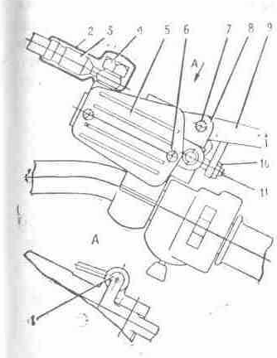
Fig. 25. The drive of a hydraulic brake:
1 - switch "stop"; 2 - jacket; 3 - hose pipe; 4 - bolt; 5 - cover; 6 - screw; 7 - axis; 8 - body; 9 - lever; 10 - lock nut; 11 - screw adjusting

Assembly of the brake to conduct in the following order: to shift the cylinder piston inside of bodies of a grip, to turn a body in initial position on the routing pin, to fix a body from guide of chocks by a bolt with a lock nut.
In case of removal of a brake disk, it is necessary to make a label on the disk and hub of a sprocket. The installation to make on labels.
Replacement of brake fluid in a hydraulic drive of the brake of a forward sprocket
The brake fluid (tab. 2) is applied to charging a hydraulic drive of a forward sprocket. For replacement of a liquid:
- to turn out screws 6 to remove a cover 5 (fig. 25) main brake cylinder and diaphragm;
- to remove a cap from the valve of air discharge 1 (fig. 26), on the head of the valve dressing a rubber handset, second end by which one to lower in over-flow capacitance and to turn unscrew the valve on 1... 1,5 revolutions;
- depressing on the lever 9 (fig. 25) brake of a forward sprocket to drain a liquid from a system, adding in a main brake cylinder fresh brake fluid so long as in all system there will be no replacement of a liquid, to monitor, that the liquid completely from a main brake cylinder did not leave;
- when from a rubber handset the fresh liquid will follow, to stop deleting a liquid, having postponed the stall the valve of air discharge.

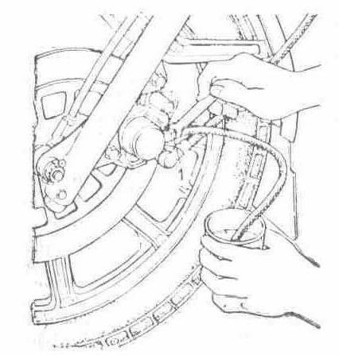
Rice 26. Replacement of brake fluid:
1 - valve of air discharge

In case of hit of air in a hydraulic-circuit system and for the control of a brake assembly after replacement of brake fluid, it is necessary to conduct deaerating. For this purpose:
- to load the end of a rubber handset which was dressed on on the valve of air discharge, in capacitance charged by brake fluid;
- to click it is sharply 3... 4 times on the lever 9 (fig. 25) brake of a forward sprocket and, retaining the lever of the brake pushed -in to turn unscrew on 1... 2 about the valve of air discharge on 1/4 revolutions, that from a brake assembly there was air (bubbles in capacitance). This operation to repeat up to a end of a deaerating from a hydraulic-circuit system;
- retaining the lever of the brake pushed -in to wrap up before failure the valve of air discharge and dressing a cap;
- to fill in with brake fluid a main brake cylinder on a level up to 2/3 altitudes of a handhole;
- to establish the diaphragm, cover to wrap up screws;
- at handicapping прокачки of a brake assembly to test reliability of connections in hose pipes and at necessity to tighten places of connections.
Regulation of the brake of a back sprocket.
To establish the lever of the brake of a back sprocket 3 (fig. 9) hook, that in an extreme upper position he rested on a cylinder 4 steps of the driver, and with an adjusting screw (fig. 27), arranged in a casing of a sprocket to supply free running of a pedal of the lever of the brake downwards on 5... 15 mms.

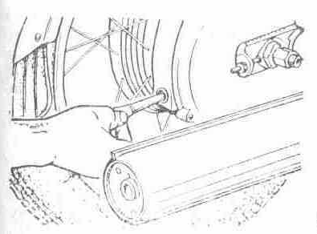
Fig. 27. Regulation of the brake of a back sprocket

Regulation of the two-jaw brake it is drumtype.
Regulation to make in the following order:
- remove strand and to take out the pin from connection of thrust with the left-hand short lever. With the help of a screw adjusting 5 (fig. 23), at untwirl which one the backlash between chocks and brake drum reduces, to adjust a tension of a rope of the brake so that at rotation of a sprocket the lower chock concerned about a brake drum after that to wrap up an adjusting screw on 1/2 revolutions;
- by turn of the left-hand lever clockwise to bring the upper chock before contact with a brake drum of a sprocket and to adjust thrust 2 so that a backlash between a chock and brake drum was least and provided rotation of a sprocket without contact about a chock. At a straddling of foramens to adjust length of thrust, having eased a lock nut. To paste the pin into a foramen of the left-hand lever and thrusts and to cotterpin;
- to establish free running 10... 20 mms on the end of the lever of the brake of a forward sprocket. The contact of brake shoes about a barrel is not enabled. The coefficient of wear of brake shoes is determined by a position of a check box 4 (fig. 23). The marginal wearing corresponds to concurrence of a check box with neat "1" on a cover of a brake drum at squeeze out the lever of a hand brake. At assembly a check box to establish on a label "0" (lever of the brake is not paired to a rope). After regulation of the brake the check box will take a position between labels "0" and "1".
For improvement of activity of the drive of the brake of a forward sprocket in the vernal-autumnal season we recommend a cable rope of a rope of the forward brake to oil motor automobile or brake fluid, and adjusting screws to dispose a groove downwards. The lubrication is made by dipping of a cable rope in capacitance with oil and subsequent movings of a shell (5-10 times) on a cable rope.

5.3.8. Circuit of the drive of a back sprocket

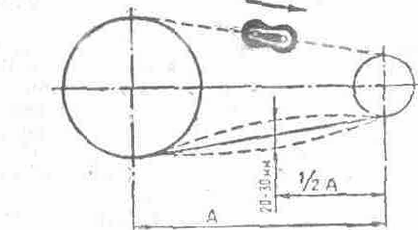
Fig. 28. The installation of the latch of the lock of a circuit, control of a tension of a circuit

For deposition of lubrication on a circuit to separate the lock to remove a circuit, to flush and to plot lubrication (see tab. 2) or to remove a dextral cover of a casing and, turning a back sprocket to plot on a circuit lubrication. At assembly circuit links to connect by the lock, latch to establish by a cut in the party inverse to motion of a circuit (a fig. 28).
Tension of a circuit to check up by clicking the lower rubber jacket of a circuit hill up and downwards on middle of a jacket (fig. 28). At moving of a circuit more than 30 mms to tighten it, changing a position of an axis of a back sprocket by a nut 3 (fig. 29). Having adjusted a circuit to wrap up nuts of an axel, axis and tie rods. In case of a large extract of a circuit to truncate it on two links, using a coupling link and tool from a complete set. At regulation of a circuit to monitor, that the sprockets were in one plane. Regulation of the installation of sprockets in one plane to make on risks on the pendulous fork and ledges of tie rods of a circuit. After tension control of a circuit it is necessary to make regulation of the brake of a back sprocket.

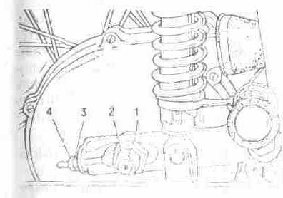
Fig. 29. Tension control of a circuit:
1, 2, 3 - nut; 4 - lock nut

5.3.9. Reduction gearbox of a speedometer
The service of the reduction gearbox of a speedometer is encompass byed to lubrication of pinions. For this purpose to remove a casing of the disk brake to turn unscrew a bolt, to take out a flexible roller, bush a cone. To flush and to lubricate parts. Assembly to make in return sequence.

5.4. Electric equipment
The scheme electrical is given on an insert. The electric equipment of a motorcycle actuates:
- sources of electrical power - battery accumulative and generator;
- the device of regulation - rectifier - voltage regulator;
- devices of ignition - induction coil, sensor, switchboard and ignition plug;
- devices of illumination and signalling system - head lamp, the rear canopy, lanterns of turn indicators, sound сиг has gorged (for a motorcycle with a lateral trailer a follow-up forward dimensional lantern and rear canopy);
- control instruments and control - ignition switch, indicating lights, interrupter of turn indicators, switch of a mode of illumination, disconnecting switch of a sound signal, switch of the indexes of turn, switch of a mode of illumination, switch of the signalling system by distant light, emergency shut-down of the engine, disconnecting switch of XOFF of brakes of forward and back sprockets.

5.4.1. Generator
The generator (fig. 30) alternating-current single-phase with excitation from permanent magnets.
The rotary table of the generator is established on a tumulus of a dextral axel of a crankshaft of the engine, a stator - in a cover of the generator or it is ground, fixed in a crankcase. The stator has two separate winding: charging and power. The charging winding is connected directly to the switchboard and serves for a feed of an ignition system of the engine, the power winding through rectifier-regulator provides a feed of devices of illumination, signalling system and battery charging accumulative.

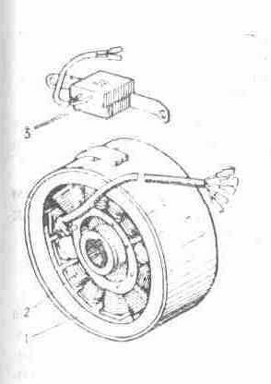
Fig. 30. The generator and sensor of ignition:
1 - rotary table; 2 - stator; 3 - sensor of ignition

A feed of a system of ignition implements an alternating current, remaining customer - through rectifier-regulator of voltage by a direct current.
The generator has no sliding contacts and friction of parts, its service is reduced to overseeing by a condition of an electrical insulation, connections of wires both security of attachment of a rotary table and stator.
The serviceability of a generating set (generator - rectifier-voltage regulator) is checked up with the help of the voltmeter of a direct current with a scale graduation value 0,1 In. The voltmeter is hooked up to the terminal "+" rectifier-voltage regulator and "-". On mean engine speed at hooked up battery accumulative and live distant light of a head lamp the voltage should be 13,7... 14,7 V. The deviation of voltage from indicated values testifies to fault of a rectifier - voltage regulator or generator.
Removal of the generator from the engine to make in the following order:
- to disconnect wires of the generator and sensor of ignition from a rectifier - voltage regulator, switchboard, main bundle;
- to remove a cover of the generator with a stator to turn out four screws of attachment of a stator and screw of a grip of attachment of wires to a cover of the generator, to disconnect a stator from a cover of the generator;
- to turn out a bolt of attachment of a rotary table, using as a puller a screw from adaptation for выжима of an axis of a chain link (to screw it in the arbor of a rotary table) to remove a rotary table.
If the stator is established ground, fixed in a casing, to turn unscrew four screws of attachment of a stator to the basis, to remove a stator with a bundle.
The installation of the generator to make in return sequence.

5.4.2. Accumulator battery
The accumulator battery is the power source at an inoperative engine. The terminal "-" battery incorporates with "-" of a motorcycle. The return hooking up of terminals is invalid, as results in mortality of electronic devices, other clusters of electric equipment and battery.
Actuating, exploitation and service of the battery are described in the affixed maintenance instruction of the battery accumulative.
In bridge accumulative батарее the condenser by capacitance 2200 mF, intended for smoothing of oscillations of rectified voltage and maintenance of normal activity of customers of the electric power of a motorcycle is connected at mortality of an accumulator battery or its absence.

5.4.3. Rectifier-voltage regulator
The rectifier-voltage regulator (fig. 31) or voltage regulator is intended for a rectification alternating-current of generator, maintenance of voltage of the generator, in predetermined thresholds and maintenance of a reliable operation of all system of electric equipment, hooking up which one in a system variously (see scheme electrical in the appendix 6).

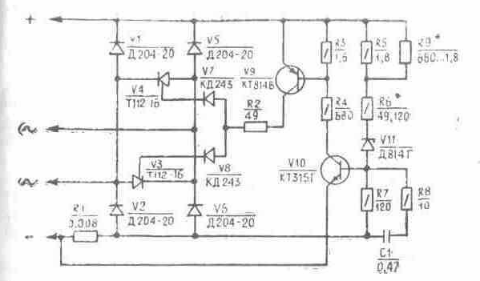
Fig. 31. The scheme of a rectifier-voltage regulator BPV 21-15

In order to prevent violation of thermal operational mode of the rectifier - regulator in batches (not less often than once per six months) it is necessary to clean by its sweeper of dust and other contaminations. Is not enabled to dust by metallical subjects and to upset a factory seal in the season of guarantee run of a motorcycle.

5.4.4. Installation of ignition
The initial lead angle of ignition is determined by a positional relationship of the sensor of ignition and rotary table of the generator, on-stream to regulation is not subject. At engine run the ignition system automatically changes a lead angle of ignition depending on crankshaft speeds.

5.4.5. Switchboard electronic
The switchboard electronic, is intended for accumulation of energy giving by the generator, and transmission it on an induction coil.
The switchboard is executed in a plastic hermetically closed body, that eliminates hit of a moisture. Maintenance does not demand, to repair is not subject.

5.4.6. Sensor of ignition
The sensor of ignition (fig. 30) is intended for creation of a control pulse for the switchboard of ignition. On-stream maintenance does not demand also to repair is not subject.

5.4.7. Induction coil
The induction coil (fig. 32) is intended for transformation of energy, stored in the switchboard, in a high-voltage impulse given on an ignition plug. On-stream it is necessary to clean a coil of dust and other contaminations.
To repair is not subject.

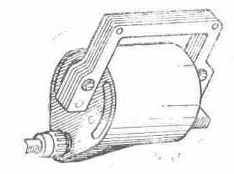
Fig. 32. An induction coil

5.4.8. Ignition plug
Through 2500-3500 kms to check up a condition of a suppository, at a fouling and oiling to flush I shine in clean gasoline and to dry.
Backlash between welding rods of a suppository to test by a probe. At regulation of a backlash is cautious to turn in a lateral welding rod. I shine in a jack to establish with the O-ring.

5.4.9. Tip Ignition plug
Tip Ignition plug (the fig. 33) connects an ignition plug to a high-voltage wire of a coil of ignition and provides a decrease of radio interference to the permissible norms. It is on-stream recommended in batches to check for security of attachment of wires in a tip and in an induction coil, to purge a tip with the purpose of dusting off between a screen and body, to wipe a tip inside. The wire should be screwed in a tip against the stop.

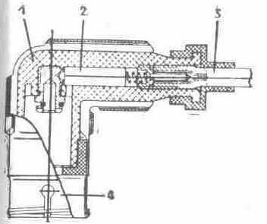
Fig. 33. A tip Ignition plug:
1 - body; 2 - resistor; 3 - wire; 4 - screen

5.4.10. Head lamp
The head lamp has two lamps: main light with two threads (short-range and distant light) and lay light. For best usage of light qualities and reduction of blinding operating the head lamp is necessary for adjusting. Before regulation a motorcycle to establish on to a horizontal site perpendicularly to a Screen apart 10 m. Load on a motorcycle at regulation - driver. Regulation to make at live short-range light pursuant to sectoring a screen (fig. 34), thus the longitudinal vertical plane of symmetry of a motorcycle should be intercepted with a screen through link AB.

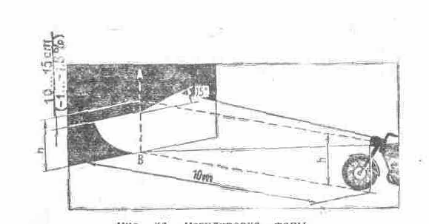
Fig. 34. Regulation of a head lamp

5.4.11. Disconnecting switches of XOFF of brakes
The disconnecting switches of XOFF of brakes of forward and back sprockets serve for actuation of a light signal at inhibition of a motorcycle. Regulation of a time of engagement of a signal in random change of a position of the lever of the brake of a back sprocket to make by a runway of the disconnecting switch 1 (fig. 35) at its loosened attachment. The lamp of XOFF should ignite prior to the beginning inhibition of a sprocket.
The disconnecting switch of XOFF of the brake of a forward sprocket is established in a bracket of the lever of the brake of a forward sprocket and regulation does not demand.

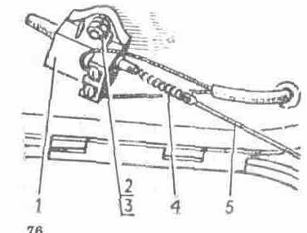
Fig. 35. Regulation of the disconnecting switch of autopodiums - сиг-нала:
1 - disconnecting switch of XOFF; 2 - screw; 3 - nut; 4 - spring; 5 - thrust

5.4.12. Sound signal
The sound signal of maintenance does not demand. The regulation of force of sounding can be made by an adjusting screw arranged on a body.

5.4.13. Fuse
The fuse consists of bodies 1 (fig. 36), cover 3 and fuse 2 on 10 А.
The safety device is adjoined to the terminal "+" rectifier-regulator of voltage.
At combustion of a fuse to eliminate the cause called combustion, and to exchange it, having separated a body with a cover.
To keep track of by a condition contact connection of the safety device, cleaning them from contamination.

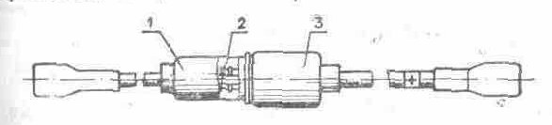
Fig. 36. The fuse:
1 - body; 2 - fuse; 3 - cover

5.4.14. Interrupter of the indexes of turns
The interrupter of the indexes of turns IZHRP-4 (fig. 37) is intended for discontinuing the power supply circuit of caution lights of the indexes of turns and control of serviceability of these lamps.
The interrupter of the indexes of turns having arranged on the cradle under the petrol tank. He has protection against short circuits in a circuit of caution lights and maintenance does not demand. To repair is not subject.

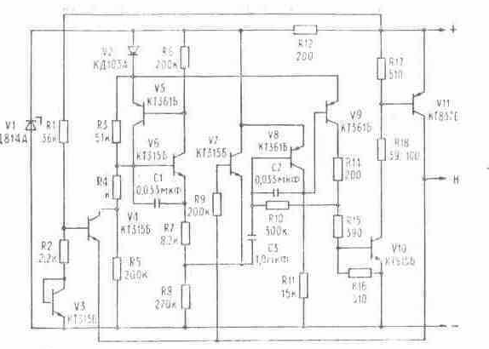
Fig. 37. The electrical principal diagram of the interrupter of the indexes of turns IZHRP 4:
"+" - positive conclusion; "-" - negative conclusion ("weight"); Н - conclusion of load

5.5. Kinds and periodicity of maintenance
The maintenance actuates washing, refuelling, lubricating, monitoring, fastening, adjusting and other kinds of activities. On periodicity and the labour inputs of works on hand are subdivided into daily services (DS), first technical service (TS-1), second technical service (TS-2).
Daily services to make before each departure.
The periodicity TS-1 and TS-2 is established on transverse depending on the operation conditions (see tab. 6, 7), but not less often two yearly for TS-1 and one time annually for TS-2.
The lubrication chart of a motorcycle is rotined in a fig. 38.
The table 6
The characteristic of the operation conditions | Periodicity of maintenance, km
The characteristic of the operation conditions | TS-1 | TS-2
Urban and country roads predominantly with asphalt and other improved firm cover. | 3000 … 3500 | 6000... 7000
Country roads with road metal, grit and other cover located in a satisfactory condition. | 2500... 3000 | 5000.... 6000
Ground, mining or faulty roads with road metal, grit, boulder or other; by cover. | 3000... 4000 | 1500.... 2000

5.5.1. Order of maintenance
The table 7
Categories of maintenance | Kinds of works on hand
DS | 1. To conduct a visual inspection of a motorcycle, fuelling.  2. To check up activity of gears and devices according to the requirements of the rules of road motion.  3. To examine a condition of trunks and to check up pressure in them (through each 7... 10 days of exploitation or parking).  4. To control a level of brake fluid in the tank of the barrel of a hydraulic drive of the brake of a forward sprocket.
The notices. | after run by a motorcycle maiden 400... 600 kms to execute following operations:  1. To conduct a tightening of screwed joints.  2. To exchange oil in a gear box.  3. To test and to establish a backlash in bearing boxs of a control pillar.  4. To test a tension of spokes of sprockets, if necessary to conduct tightening.  5. To test a condition and operating of brakes.  6. To test a tightening of screws of attachment of an oil pump, unions of attachment of an oil line. Before removal of a cover of capacitance it is necessary to turn out a bolt of a spout hole, to drain oil. To not enable contamination of oily capacitance.
TS-1 | 1. To test a tightening of threaded connections.  2. To plot lubrication LItol-24 or ZIATIM-201 on:  - a hinge of the lever of a clutch on a control surface;  - a hinge of the lever of the brake of a forward sprocket;  - the bush of the lever of the brake of a back sprocket.  3. To test a condition and braking action, to adjust them. For a hydraulic drive to make drawing of a system, if necessary to test a condition of brake pads. At wearing of a friction layer up to 1 mm - to exchange.  4. To test and to adjust a tension of a transmission circuit on a back sprocket, to gob up lubrication in protective jackets.  5. To exchange oil in a gear box (hereinafter given operation to conduct on even TS-2).  6. To flush glands of hydraulic shock absorbers of the forward fork.  7. To test a condition of a suppository, to adjust backlashes between welding rods of a suppository, to wipe by dry cloth an induction coil and shank bore of a tip ignition plug.  8. To test a tightening of screws of attachment of an oil pump, having removed a cover of oily capacitance, unions(pipe connections) of attachment of an oil line.
TS-2 | before to initiate with fulfilment That to make activities, foreseen for TS-1, and is padding:  1. To eliminate a burn from exhaust channels of the barrel, in the head of the barrel, from the back end and from flutes of the cylinder piston.  2. To plot lubrication Litol-24 or ZIATIM-201 on:  - of a cone of the reduction gearbox of a speedometer;  - of an axis and clutch prongs and slotss of brake shoes;  - cords and commercial films of ropes;  - bearing boxs of sprockets and bearing box of a sprocket of a back sprocket.  3. To test a tension of spokes, to make test screws.  4. To flush petrol crane, carburettor, to blow out by air channels and metering jets of the carburettor.  5. To test attachment of a rotary table, stator and condition of electrical connections.  6. To exchange a liquid in hydraulic shock absorbers of the forward fork, suspensions of a back sprocket (on even TS-2).  7. To flush by gasoline the filter of a port of oily capacitance.  8. To flush by gasoline shank bore of oily capacitance (on even TS-2).  9. To flush an air cleaner and to slosh in it oil.  10. To conduct cleaning a tone filter of a silencer (on even TS-2).  11. To disassemble lanterns of the indexes of turns, to wipe lamps and scatterers, to clean contacts.
The notices. | 1. Maintenance behind an accumulator battery to make according to the appended instruction of a manufacturing plant.  2. Operation of clearing of shank bore of lanterns of turn indicators follow-up to conduct in process of their contamination

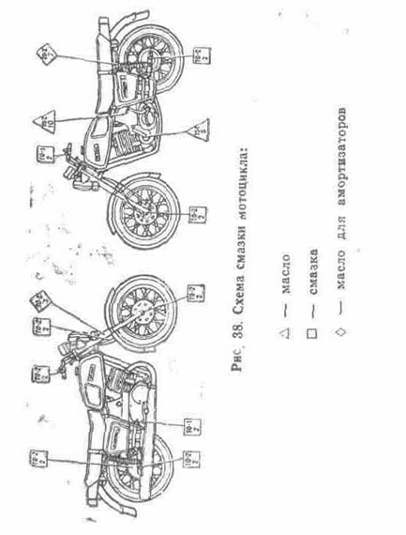
Fig. 38. The lubrication chart of a motorcycle:
oil
butter
oil shock-absorbers

5.6. Possible troubles of a motorcycle
The table 8
Defect symptoms | A possible cause of the trouble | Finding of the malfunction | A method of elimination
The engine
The engine is got | the fuel in the carburettor | moves at clicking on press of a float of the carburettor fuel does not follow from the float chamber | to disassemble and to clean the power supply system
The engine is got | Quantity of a condensate of fuel in chankraft to the chamber was increased, the ignition plug is bombarded by fuel | is determined visually. For the turned out ignition plug isolator wet | to bar petrol crane to clean I shine, to blow out the barrel, using a decompressor
The engine is got | The ignition system is defective | see tab. 9
The engine is not got or is got arduously, works with faults | skips the valve of the float chamber of the carburettor (is contaminated or is disturbed) | fuel the engine hardly smoke follows from the carburettor, does not gain speed | to clean the valve of the float chamber of the carburettor or to exchange a sealing ring of the valve
The engine is not got or is got arduously, works with faults | The ignition system is defective | see tab. 9
The engine is not got or is got arduously, works with faults | The gasket between the barrel is damaged and casing | are fumed or the condensate under the barrel | has appeared to remove the barrel and to exchange the gasket
The engine is not got or is got arduously, works with faults | The glands of a crankshaft have worn | is determined visually | glands to exchange
The engine is not got or is got arduously, works with faults | The gaskets of a suction connection are damaged or ease the attachment | is determined visually | gaskets to exchange or to tighten nuts
The engine is not got or is got arduously, works with faults | Eased attachment of a body of a dextral gland to a casing | on the generator the tracks of fuel have appeared. The engine arbitrary augments revolutions | to remove the generator, to fix screws of a body of a gland
The engine is got, but is fast stop the ambassador began motions | the foramen in a cover of the petrol tank | has got littered at a removed cover the engine works | to clean a foramen in a cover
 | The needle of the carburettor in the mixing chamber has falled | is determined visually | to establish a needle on a place and to fix by the latch
The engine unstably works under power, does not develop power | the metering jets have got littered the carburettor | is determined visually | to disassemble and to blow out metering jets
 | Too rich mixture | to test a level of fuel in the carburettor, leakage of the valve of the float chamber | to adjust a level of fuel in the carburettor.
 |  |  | To clean the valve of the float chamber of the carburettor or to exchange a sealing ring of the valve
 | The filter pack of an air cleaner has got littered | is determined visually | to flush a filtrating member in gasoline
 | In an outlet system, including channels of the barrel, the burn was accumulated | is determined visually | to eliminate a burn from a tail pipe, from a tone filter of a silencer and channels of the barrel
 | The attachment of a partition (separation from bodies) | is disturbed to test spacing interval from back butt end of a body up to the maiden partition. Spacing interval should be 180... 182 mm | to exchange a silencer
 |  | To test engine run with a silencer, the quality which one is checked in activity
Clutch and releaser
Overshoots the lever of a releaser in winter time | the increased oil body in a gear box |  | to apply "winter" kinds of oils
Overshoots the lever of a releaser in winter time |  |  | To slosh in a gear box 0,1... 0,15 l of gasoline
The coupling skids | the compression disk at clicking the lever departs with a skew | shaped nuts of a clutch | nonuniformly are delayed to adjust uniformity of withdrawal of the disk by shaped nuts
The coupling skids | The drive of control of a clutch | is not adjusted there is a free running of a clutch lever | to adjust the drive of coupling
The coupling completely is not switched off, "conducts" | the free running of a clutch lever | Easy screws of attachment of a dextral cover of a casing | was increased to test and to fix a dextral cover, to adjust the drive of coupling
Lubricating system of the engine
The caution light OIL in shield of devices does not glow at live ignition and inoperative engine | the lamp | 1 has fused. At short circuit of a jack of a wire of the valve - sensor on "-" the lamp does not burn | to exchange a lamp
 | the lamp | 2. To open shield of devices and to test the validity of a lamp | to clean contacts
 | The electrical wire of the valve - sensor | is damaged at short circuit of a wire of the valve - sensor on "-" a properly functioning lamp does not burn | to eliminate damage of a wire
 | There is a contact in the valve - sensor | to remove a cover of an oil pump. By inspection of contacts and clicking the cylinder piston of the valve - sensor to test purity of contacts and motility of the cylinder piston | to flush, if necessary, contacts and cylinder piston
The caution light OIL glows at a running engine | closes on "-" a wire of the valve - sensor | is determined by inspection of a wire and its connections | to eliminate short circuit of a wire
The caution light OIL glows at a running engine | The oil pump does not work because of a defect of the drive | to remove the left-hand cover of a casing, to test the coupling and trailing-edge of the arbor of an oil pump | to exchange the coupling or oil pump in case of a defect of a trailing-edge of the arbor
The vesicultion of air in a transparent oil line of a fitting pipe of the engine | leakiness of connections in a system of an oil line from the pomp to a fitting pipe of the engine | is determined visually at removal of a cover of oily capacitance | to eliminate leakinesses
There is an oil in a transparent oil line of a fitting pipe of the engine after long-lived parking | outflow of oil through leakinesses of connections of an oil pump and oil lines or the oil line | is damaged is determined visually | to eliminate leakinesses of connections or damage of oil lines
The fork telescopic
Quantity of oil in hydraulic shock absorbers knocks in the fork | below than norm or the poor oil body | is determined visually | to add oil. To exchange oil with reference to the operation conditions
The oil from pens of the fork | Eased attachment of a body of a gland flows or the mud on a gland | has got is determined visually | to fix a body of a gland or to flush a gland
The tightening of the damper | is not adjusted sinks down a brake disk for butt end of a cylinder of a control pillar | the damper the inhibition of turn of a control surface | the lower disk of the damper centered on a cylinder of a control pillar does not adjust then to wrap up the handle of the damper
The generator and rectifier - voltage regulator
At a running engine:
· customers of the electric power completely do not work | has fused the safety device | is determined visually | to exchange the safety device
· customers of the electric power completely do not work | The electric network | on idle speed of the engine is disturbed to test a terminal voltage "+" and "-" BPV: - the voltage should be 13,2... 15 V | To eliminate violation of an electric network
· customers of the electric power completely do not work | The generator is defective or BPV | · the voltage no | to exchange the generator or BPV
· of a lamp burn in half-heat, the lanterns - indexes of turn do not work | there is no contact between BPV, by an accumulator battery and condenser | is determined visually | to eliminate violation of an electric network
The lamp of a lantern - turn indicator does not burn, and second flashes with the doubled frequency | the lamp has fused or rusted contacts | is determined visually | to exchange a lamp or to clean contacts
The lamps of lanterns - turn indicators | do not burn there is "-" on the relay assembly - interrupter of turn | is determined visually | to restore connection
The lamps of lanterns - turn indicators | The breakaway of wires | is determined visually | to restore connection
The lamps of lanterns - turn indicators | The failure of the relay assembly - interrupter of turn | is determined by replacement of a unit | to exchange a faulty node
The brake
The efficiency of the brake of a back sprocket | is small the free running of a pedal of the lever of the brake is increased or the plates |  | have worn to adjust free running of a pedal
The efficiency of the brake of a back sprocket |  |  | Plates to flush in clean gasoline and dry to wipe, if necessary to establish adjusting spacers under a footstep of chocks
The efficiency of the brake of a forward sprocket | is small the free running of the lever of the brake is increased, the plates of brake shoes | by clicking the lever of the brake of a forward sprocket and inspection of a condition of plates | have worn to adjust free running of the lever with the help of an adjusting screw
The efficiency of the brake of a forward sprocket |  |  | To exchange chocks
The efficiency of the brake of a forward sprocket | The hit of air in a system of a hydraulic drive | at clicking the lever of the brake of a forward sprocket misses an abutment stop | Pomp a system of a hydraulic drive
The efficiency of the brake of a forward sprocket | The leak of a liquid through seals | is determined visually | to eliminate bowse in
The table 9
Technique of detection of the causes of faults of an ignition system
Defect symptoms | A possible cause of the trouble | Finding of the malfunction | The detected fault and method of elimination
Is not kick offed | there is a scintilla on welding rods of a suppository | to turn out I shine, to put it on the head of the barrel, to include ignition and to click the lever of a releaser:
Is not kick offed |  | · the scintilla is: | the ignition system is serviceable
Is not kick offed |  | · the scintilla no:
Is not kick offed |  | To turn out a high-voltage wire from a tip ignition plug and to test availability of a scintilla between a high-voltage wire and head of the barrel, having clicked on the lever of a releaser:
Is not kick offed |  | · the scintilla is: | are defective a suppository or tip ignition plug. To furbish I shine from a burn, to wipe isolator by a dry napkin, or to exchange it; to wipe a cavity of a body of a tip or to exchange it
Is not kick offed |  | · the scintilla no:
Is not kick offed |  | To disconnect from the terminal "+" induction coils an orange wire. To connect between an orange wire and "-" of a motorcycle an indicating light by voltage 12 In and power no more 1W (for example, from shield of devices the indicating light of a neutral position) and needs to be clicked the lever of a releaser:
Is not kick offed |  | · the lamp flares: | violation of an electric network of an induction coil to eliminate violation of a circuit
Is not kick offed |  |  | The induction coil is defective, to exchange a coil
Is not kick offed |  | · the lamp does not flare:
Is not kick offed |  | To disconnect from a wire bundle a blue wire going to the generator. To connect an indicating light to a blue wire of the generator and "-" of the engine and to click the lever of a releaser:
Is not kick offed |  | · the lamp flares: | the circuits of hooking up of the switchboard or sensor are disturbed.
Is not kick offed |  |  | Are defective the switchboard or sensor. To test hooking up of the switchboard and sensor. To exchange the switchboard
Is not kick offed |  | · the lamp does not flare: | the generator is defective.
Is not kick offed |  |  | To exchange the generator
Is not kick offed | The sensor of ignition | is defective to disconnect a grey wire of the sensor of ignition from the switchboard. To connect an indicating light to "+" accumulator battery and seroma to a wire of the sensor of ignition:
Is not kick offed |  | The lamp burns semi-light | the sensor is serviceable
Is not kick offed |  | The lamp does not ignite or burns in full heat | the sensor is defective
Is not kick offed |  |  | To exchange the sensor
Is not kick offed |  | The serviceability of a winding of the sensor also is determined by a tester by sensing resistance of a winding, which one should be 200+-20 Om

6. CONSERVATION AND STORAGE
Before conservation a motorcycle to wash. In oily capacitance of a separate lubricating system of the engine to slosh oil (see tab. 2) up to a level of a handhole. To disconnect wires from accumulator battery, through a foramen under shine in the barrel to slosh 25... 30 sm3 of oil (see tab. 2). By clicking a pedal of the lever of a releaser to turn a crankshaft, that oil misses on an internal surface of the barrel. The surfaces chrome-plated and zincuming of parts which are being a subject temporary anti-corrosion to protection, should be dried. Deposition conservation oils on outside surfaces of parts is made paintbrush (wad), wetted in oil motor automobile or conservation K-17.
Outlet holes of a silencer to bar by an oiled paper.
At storage a motorcycle to establish on a central support.
To store a motorcycle indoors or under a shed.
To not store a motorcycle near to heating batteries, acids, alkalis, mineral fertilizers and other aggressive means.
At activation a motorcycle to wipe by cloth, wetted gasoline or kerosene, then to wipe dry.
Before launch of the engine to eliminate oil filled for conservation in the barrel. For this purpose to establish a neutral position in a gear box and some times to click па the lever of a releaser at the open decompressor.
Before departure after activation to conduct activities indicated in section "Opening-up of a motorcycle to exploitation".
Shelf life of a motorcycle with factory conservation 12 months without new conservation.

7. WARRANTY AND ORDER OF ASSERTION OF THE CLAIMES
OAO "Izhmash" guarantees serviceability of a motorcycle as a whole, and also normal activity of separate aggregates, gears and parts within 20 months from the date of sale of a motorcycle under condition of run no more than 17000 kms.
The notice. At exploitation of a motorcycle with a lateral trailer the guarantee run decreases on 1/3 or on 1/2 with the installation of a cargo module.
During a warranty the charge-free replacement of parts and clusters prematurely out of service (except for trunks and accumulators) is made if the motorcycle was exploited and was stored pursuant to the requirements and indicatings of the present manual. The warranty for an accumulator battery is set up in the appended instruction of a manufacturing plant.
The warranty period of storage of trunks (agrees a GOST 5652-89) - 5 years from the date of manufacturing.
Guarantee operating time(running time) of trunks - 24000 kms.
At replacement in a warranty any of the device, gear or aggregate guarantee period on a motorcycle prolongs on a dwell-time under repair.
The guarantee certificates are not diffused in cases:
- defaults by the holder of the requirements of the operation manual of a motorcycle, including indicating on application of operational stuffs (gasoline, lubricants and т. Item);
- the expirations of an established warranty period;
- of absence of defective clusters and parts;
- depositings of independent changes into a design of a motorcycle;
- disassemblies or repair of a defective unit without the sanction of servicing deport (STO) OAO "Izhmash";
- usages of a motorcycle in the sporting or educational purposes.

7.1. Order and conditions of assertion of the claimes
For fulfilment of a warranty repair of a motorcycle the holder can show it on one of nearest STO, listed in section "Addresses of stations of a warranty repair of motorcycles", thus he should have at itself the technical passport of a motorcycle and thawed on a warranty repair of a motorcycle.
The holders not having capabilities to show a motorcycle on one of the indicated stations, within three days from the moment of faultlocation can compound the claim in the form of the letter - application and in flow of ten days from the moment of compiling to send on nearest STO or together with the guarantee coupon and scrapped part on a plant to the address: 426060,. Izhevsk, OAO "Izhmash", control "Izhtechobluzhivanie". The telephone 26-40-21.
In the letter - application should be indicated:
- Surname, name, patronymic and full mail address of the holder of a motorcycle.
- Model of a motorcycle, number of a motorcycle and engine.
- Time of obtaining (purchasing) of a motorcycle.
- Run of a motorcycle in kilometers.
- External developments of fault (noise, knocking, leak of a liquid, chattering and etc.), circumstance, at which one they have taken place (condition of a road, running speed, load and Item).
- The full naming of scrapped parts (at the claim of the aggregate, on which one is present a sequence number, to indicate number).
- Naming of the nearest railway station or water quay.
- Number of the voucher and date of shipment of defective parts.
After obtaining the letter - application STO inform a customer on the adopted solution.
The parts and clusters sent on affiliation, should be clean and are supplied with the identification tags with the indicating of an assembly number of a motorcycle.
Sending parts and clusters, the holder should supply their case packaging eliminating damage at haul.
At non-observance of the indicated conditions or about at transfer of the letter - application of the claim of the holders are not esteemed, and the letters - application return back.
In case of mortality of the generator or straighten - regulator for more impartial assessment of a defect last are sent have.
The renvoi of parts and aggregates out of service, is made railway transport by cargo speed or parcel post.
STO do not send free of charge new parts instead of sent a customer in case the parts after research in plant laboratories will appear conforming to the engineering specifications, and breaking or wearing have taken place on fault of the holder. STO do not make a warranty repair of a motorcycle in case of violation of regulations of brakes and т. Item. These violations can not be the basis for assertion of the claimes.
The claim on trunks and accumulator batteries is necessary to route to addresses:
1. On trunks:
- 610004, Kirov, bus plant
- 620087, Ekaterinburg, bus plant. The initial character of a title of a bus plant (SSHA - Sverdlovsk bus plant, K - Kirov bus plant) is put on of the tyre before its each number.
2. On an accumulator battery:
- 305013, Kursk, accumulative plant,
- 625001, Tyumen, accumulative plant.

The appendix 1. Addresses of servicing deports
- 352916, Armavir, Promzona-16, Armavirskaya autobaza sviasi STO # 54, branch OAO "Izhmash", tel. 5-21-06, (fax), code 8-861-37
- 744002, Ahgabat, street. Sevastopolskaya, 1, ZAO "Izh-Service", tel. 32-39-85, code 8-363-2
- 41610, Bishtubinka by the Astrakhan province, Narimanovski region, street. Sovietskaya, 141, STO # 61 branches OAO "Izhmash", tel. 59-52-31 (faxes), code 8-851-2
- 241004, Bryansk, Fokinski region, fare Moscovski, 11a, Severo-vostochnaya promzona, STO # 153 OAO "Izhmash", tel. 3-58-49, 3-64-89, code 8-083-22
- 308019, Belgorod, street. Gorkogo, 54, STO # 75 OAO "Izhmash", tel. 35-93-27 (faxes), code 8-072-2
- 656023, Barnaul, prospect Kosmonavtov, 3, ZAO «Altai-Izhmash-Service", tel. 77-56-72, (fax), 77-41-11 shifts team, code 8-385-2
- 665709, Bratsk, Promploshadka, GSTO # 186 branches OAO "Izhmash", tel. 36-47-93 boss, fax, 36-34-78, code 8-395-3
- 370039, Baku, pos. Mashtagi street. Nizami, 2а, SP "AzIzhservice", LTD, tel. 55-06-78, code 8-10-994-12
- 160000, Vologda, street. Burmaginih, 30, ZAO "Vologda-Izhmash-Service", tel. 72-45-18 faxes, 72-40-61, code 8-817-2
- 400014, Volgograd, Traktorozavodsky province, street. Lavrinova, 21l, STO # 12 branches OAO "Izhmash", tel. 77-96-90, 78-82-23, 78-88-13 faxes, code 8-814-2
- 391052, Voronezh, street. Ostrogojskaya, 160, STO # 69 branches OAO "Izhmash", tel. 31-29-91 (faxes), 31-85-30, 36-68-41, code 8-073-2
- 612900, Viatskie Polyani by the Kirov province, street. Lenina, 26, STO # 167 OAO "Izhmash", tel. 6 34-30, code 8-833-31
- 312450, Valki of the Kharkov province, prospect Lenina, 10а, branch «Valki-Izh-Service", tel. 5-14-69, code 8-057-53
- Vilnius, Litva, street. Apeytes, 12, Litovsko-Rossiiskoe predpriatie ZAO «Energetika-Izhmash", tel. 77-96-39, code 8-012-3
- 320046, Dnepropetrovsk, street. Shirokaya, 287, ZAO "Dnepr-Izh-Service", tel. 27-70-05, 27-07-84, code 8-056-2
- 340019, Donetsk, street. Leninskaya, 10а, SP "Donetsk-Izh-Service", tel. 22-04-99 (faxes), 22-04-57, code 8-062-2
- 734036, Dushanbe, pos. 40 let Oktiabrya, 292/2, AO "Izh-Osiie", code 8-377-2
- 620130, Ekaterinburg, street 8 Marta, 204, STO # 13 ОАО "Izhmash", tel. 22-33-24 (faxes), staff 8 343-2
- 375105, Yerevan, Jugo-zapadni massiv, street. Sherami, 50, SP "Izhservice", tel. 73-85-50, 73-86-46
- 664039, Irkutsk, street. Shmidta, 33, STO# 84 OAO "Izhmash", tel. 43-22-71, 43-24-02, 43-23-22 (center, fax), code 8-395-2
- 426060, Izhevsk, street. Avtozavodskaya, 5, DOAO "Izhtechobluzhivanie", STO # 35 OAO "Izhmash", tel. 26-70-39, code 8-341-2
- 424004, Ioshkar-Ola, street. Volkova, 56, MP «Remontno-stroitelnogo upravlenia", OOO "Izh-Mari-Al", tel. 12-88-50, code 8-836-2
- 349302, Krasni Luch, street Clary Zetkin, 54, OOO "Orbita-Izh", tel. 4-20-18 dob. 5-90, code 8-064-32
- 420101, Kazan, street. Karbisheva, 64, P # 38 OAO "Izhmash", tel. 35-48-62, code 8-843-2
- 610006, Kirov, street. Severnoe kolzo, 52, ZAO "Technical center "Izh-Servise", tel. 24-16-11, 24-17-10, 24-18-22, 24-14-65 (faxes), code 8-833-2
- 305045, Kursk, p. Volokno, ZAO "Kursk-Izhmash-Service", tel. 4-31-14, code 8-071-22
- 640014,. Kurgan, street. Omskaya, 14А, STO # 105 branches OAO "Izhmash", tel. 3-07-50, code 8-352-22
- 350005, Krasnodar, street. Konechnaya, 2/1, GSTO # 8 OAO "Izhmash", tel. 58-37-80 (faxes), code 8-861-2
- 156013, Kostroma, prospekt Mira, 51, STO # 67 branches OAO "Izhmash", tel. 55-75-32, 8-094-2
- 247009, Kaluga, Grabzevskoe shosse, 68/5, ZAO "Izh-Delta", tel. 2-79-81, code 8-084-22
- 650015, Kemerovo, street. Trubnaya, 14, CTO # 56, branch OAO "Izhmash", tel. 4-36-38, 25-25-90 (center, fax), code 8-384-22
- 660061, Krasnoyarsk, street. Kalinina, 60, p.o. 13862 STO # 30 OAO "Izhmash", tel. 26-01-98, code 8-391-2
- 353610, staniza Leningradskaya Krasnodar territory, street 302 Divisii, 18, STO # 178 OAO "Izhmash", tel. 3-2697, code 8-861-45
- 252090. Kiev, street. Sivashskaya, 14а, SP "Kiev-Izh-Service", tel. 574-18-33, 574-19-11 (faxes), code 8-044
- 3000, Kaunas, Lithuania, p.o. Domeykawa, street. Peres, 4, INS, ZAO«CSM-IZHMASH ", tel. 55-36-79, 2053-13 (faxes), code 8-10-370-7
- 427760, Mozhga, street. Mozhginskaya, 32, STO # 166 branch OAO "Izhmash", tel. 3-90-79, code 8-239
- 129337, Moscow, street. Fedoskinskaya, 12, ZAO "Izhmash-service", tel. 183-35-80 (faxes) 18354-23, 182-98-81, 188-11-33 acc., code 8-095
- 367011, Makhachkala, 1, pos. Krasnoarmeysk, street. Komsomolskaya, 2, STO # 106 OAO "Izhmash", code 8-872-2
- 223054, Ostroshitski gorodok, Minsk area, street. Lenina, 49, OOO "Bel-Izh-Service, tel. 94-96-91, 36-30-84 (faxes), code 8-10-375-172
- 603038, Nizhni Novgorod, street. Kima, 86, STO # 20, OAO "Izhmash", tel. 73-03-95, 73-16-92 (faxes), code 8-831-2
- 147407, Noginsk by the Moscow province, street. Magistralnaya, 62, STO # 10 OAO "Izhmash", tel. 4-78-93, code 8-096-51
- 630058, Novosibirsk, street. Russkaya, 46, AOZT "Techcenter Izh, tel. 39-12-35 (faxes), 32-02-92, code 8-383-2
- 270041, Odessa, street. Hadjibeevskaya doroga, 32, SP "Odes-Izhservice", code 8-048-2
- 460826, Orenburg, street. Montajnikov, 23, CTO # 64 OAO "Izhmash" tel. 3547-33, 35-31-27 (faxes), 35-37-42 res.., code 8-352-2
- 044086, Omsk, street 21-ya Amurskaya, 236, ZAO "Omsk-Izhmash-Service", tel. 21-58-55 (faxes), code 8-381-2
- 357532,. Pyatigorsk, street 295 Strelkovoi divisii, 15, TOO "Planet-4", tel. 9-44-34 (faxes), 9-99-29, code 8-865-33
- 440054, Penza, street. Austrina, 36, ZAO "Torgovo-techniteski center "IZHMASH", tel. 57-88 16, 57-95-90 boss, 57-90-90 (faxes), code 8-841-2
- 614093, Perm, street Geroev Hasana, 117, STO # 17 OAO "Izhmash", tel. 40-5385, 33-09-19 (faxes), code 342-2
- 180019, Pskov, street. Truda, 38, STO # 155 branches OAO "Izhmash", tel. 72-43-35 boss, 72-43-45 acc., code 8-811-22
- 659413, selo Pervomaiskoe of Altay Territory, Biiski area, Togulsky tract, 10, STO # 119 OAO "Izhmash", tel. 77-57-74, 71-12-11 faxes, code 8-385-4
- 384640, Senaki, Suhumskoe shosse, 1, SP "IZHSERVICE"
- 333019, Simferopol, pos. ERAS, street. Montajnaya, 8, SP "KRIMIZHSERVICE", tel. 22-14-29, 25-1155 (faxes), code 8-065-2
- 703018, Samarkand, street. Spitamena, 157, STO # 55 OAO "Izhmash", tel. 21-77-00, 21-76-59, 21-43-03 (faxes), code 8-366-2
- 331882, Sudak, Crim, street. Feodosiiskoe shosse, 10, SP "JUG-SERVICE-LTD", tel. 2-34-82, code 8-065-66
- 443082, Samara, street. Clinicheskaya, 255, STO # 46 OAO "Izhmash", tel. 16-49-35, 32-51-66 (center, fax), code 8-846-2
- 194902, St.-Petersburg, pos. Pargolovo, Vyborgskoe shosse, 222, STO # 7 OAO "Izhmash", tel. 513-83-15 acc., 592-15-92 (faxes), code 8-812
- 355013, Stavropol, street. Selectionnaya, 7/1, STO # 99 branches OAO "Izhmash", tel. 28-32-17, 26-55-89 (center., fax), code 8-865-2
- 410047, Saratov, street. Techniteskaya, 166, ZAO "Saratov-IZHMASH-Service", tel. 64-84-48 (faxes), 64-23-11, 64-48-28, code 8-845-2
- 430010, Saransk, street. Mokshanskaya, 16а, STO # 100 OAO "Izhmash", tel. 17-98-27 (faxes), 17-50-27, code 8-834-2
- 354055. Sochi, street. Krasnodonskaya, 36a, STO # 175 OAO "Izhmash", tel. 98-89-15, code 8-862-2
- 214009, Smolensk, village Tihvinka, 71, OOO Smolensky torgovo-technitesky center "Smolensk-IZH-service", tel. 9-73-94, 9-16-17 (faxes), code 8-081-22
- 380068, Tbilisi, Samgorski area, Gardabanskoe a highway, 5, OAO "IZH-VELI", tel. 71-74-94, code 8-10-995-32
- 700034,. Tashkent, street. Karasaryiskaya, 336а, STO # 21 ОАО "Izhmash", tel. 48 27-41 (faxes), code 8-371-2
- EE0013, Tallinn, Estonia, Parkway Kadaka, 86, Representation OAO "Izhmash", tel. 53-25-64, code 8-10-372-2
- 278000, Tiraspol, street. Ukrainskaya, 11, OOO "TIRASPOL-IZH", tel. 3-30-22, 3-21-69, code 8-042-33
- 300901, Tula, item. Gorelki, street. Bolshaya, 9, STO # 68 OJC "Izhmash", tel. 38-14-80, code 8-087-2
- 392000, Tambov, street. Moscow, 13а, STO # 150 branches OJC "Izhmash", tel. 21-17-67 (faxes), 21-04-11, code 8-075-2
- 432054, Ulyanovsk, street. Efremova, 62, OOO of «Simbirsk-auto-izh", tel. 63-07-09, 32-08-94 (faxes), code 8-8422
- 450065, Ufa, street. Svobody, 55, "«Autotechservice-Moskvich", GP # 33 OAO "Izhmash", tel. 42-17-19, code 8-347-2
- 672038, Chita, street Pervaya Chitinskaya, garage coop. # 5, STO # 37 branches OAO "Izhmash", tel. 26-49-31 (faxes), code 8-302-2
- 428000, Cheboksary, item Novie Lapsary, Industrial zone, OOO "Izhmashservis", tel. 29 4884, code 8-835 2
- 283128, village Yastrubovo by the Ternopol province, Kozovski r., branch "Terno-IZH-Service", tel. 2-80-22, code 8-035-47
- 112140, item Karachevka by the Kharkov province, mails, department. Pokotilovka, street. Jiharskaya, 88, branch of «Kharkov-IZH-Service", tel. 49-32-46, 52-80-85 (faxes), code 8-057-2
- 468050, Shimkent, street. Dzerjinskogo, representation PU "Izhtechobslujivanie" OAO"Izhmash", tel. 59-51-32, 59-51-33, code 8-325-2

The appendix 2. Weights of main assembly units
Weights of main assembly units, kg
The cradle in the assembly | 27,8
The engine | 43,0
Tyred wheel cast forward | 13,5
Tyred wheel cast back | 14,0
Saddle with back shield and bracket of a lantern | 9,2
The petrol tank | 5,2
Step of a forward sprocket with the disk brake | 13,3
Tyred wheel sprocket with spokes | 12,6

The appendix 3. Bearing boxs used on a motorcycle
Notation | a GOST, phylum | an installation site | quantity | the size
 |  |  |  | d | D | B
304 | 8338-75, ballpoint, radial single-row | an outside barrel of coupling, primary arbor | 1 | 20 | 42 | 12
203 | - » - | a crankcase, jackshaft | 2 | 17 | 40 | 12
602203 or 203 | - » - | a hub of a sprocket | 4 | 17 | 40 | 12
204 | - » - | a crankcase, primary arbor | 1 | 20 | 47 | 14
80205 or 205 | - » - | a sprocket of a back sprocket | 1 | 25 | 52 | 15
60303 | - » - | a hub of a cast sprocket | 2 | 17 | 47 | 14
301A | - » - | a crankcase, left-hand axel of a crankshaft | 1 | 25 | 52 | 15
20505 KMY 2505 AE | 8328-75, roller radial | a crankcase, axel of a crankshaft | 2 | 25 | 52 | 18
192906 CM(command module) | roller, radial | the secondary arbor | 1 | 30 | 46,4 | 13
778706 | Ballpoint radial-persistent | a control pillar | 2 | 30 | 48 | 12
941/10 | 4060-78 Bearing boxs | a dextral cover of a casing |  | 10 | 16 | 12
941/17 | - » - | - » - |  | 17 | 23 | 13
d - minor diameter
D - external diameter
B - width

The appendix 4. Glands used on a motorcycle
Number of a part | the naming of a part | the sizes, mm |  |  | quantity on a motorcycle
Number of a part | the naming of a part | D | d | B | quantity on a motorcycle
IZH 49 sb. 1-29-2 | a gland of a dextral crankshaft | 30 | 15,5 | 7,5 | 1
IZH J sb. 1-50 | a gland of the left-hand crankshaft | 52 | 24,4 | 10,0 | 1
IZH P2 4-222 | a sealing ring of a cover of a forward sprocket | 84 | 58,5 | 8,0 | 1
IZH P2 1-416 | a cap of a nut of the secondary arbor | 43,5 | 4,5 | 14,5 | 1
IZH 56 2-99-1 | a gland of a shock-absorber of the suspension of a back sprocket | 24 | 9,2 | 12,7 | 2
IZH 56 sb. 4-28 | a gland of a sprocket, arbor of a releaser | 36,5 | 21,5 | 6,5 | 3
IZH P sb. 3-10-1 | a gland of the telescopic fork | 43,4 | 32 | 8,5 | 4
IZH 49 sb.1-28-1 | a gland of the secondary arbor | 52 | 34,5 | 9,0 | 1
IZH P3 10-7-1 | a gland of the tank of a shock-absorber of the suspension of a back sprocket | 31 | 24 | 3,5 | 4
IZH P2 1-421 | a ring of the arbor of a gear-shifting | 17,7 | 13,7 | 2,0 | 1
IZH P3 10-40 | a buffer of a shock-absorber of a back sprocket | 29,5 | 9,5 | 10,0 | 4
7.105-2905690 | Sealing ring of a shock-absorber of a forward sprocket | 50 | 36,2 | 11 | 4
7.109-3101130 | Sealing ring of a sprocket of the disk brake | 47 | 27,3 | 7 | 1
7.109-3101150 | Sealing ring of the disk brake | 56 | 43,7 | 6,6 | 1
7.107-1011150 | Sealing ring of an oil pump | 17 | 6,3 | 6 | 1
D - external diameter
d - minor diameter
В - width

The appendix 5. Value of the moments of tightenings of screwed joints of a motorcycle
The naming | N*m (kgs*m)
Nut of an axis of a forward sprocket, nut of an axis of a back sprocket, nut of an axel of a casing of a sprocket, nut of a control pillar | 49,03... 60,80 (5... 6,2)
Nut of attachment of the lever of the brake of a back sprocket | 11,76... 15,69 (1,2... 1,5)
Nut of attachment of the lanterns - indexes of turn | 24,51... 31,38 (2,5... 3,2)
Nut of a holder of a control surface | 21,57.. .31,38 (2,2... 3,2)
Nut of attachment of the engine | 15, 69... 19,61 (1,6... 2,0)
Nut of a through bolt of the lower and upper bridges from carrier by a tube | 31,38... 41,28 (3,2... 3,6)
Nut coupling bolts of a forward axis | 6,86 … .9,8 (0,7.. .1,0)
Nut of attachment of the petrol tank, nut of attachment shield of a forward sprocket | 7,02 … .9,75 (0,72... 0,99)
Nut of attachment of the unit BPV 21-15, nut of attachment of an induction coil | 3,53... 4,9 (0,36... 0,5)
Bolt of attachment of a sprocket of a crankshaft | 52,92... 58,8 (5,4... 6,0)
Bolt of a speed-control mechanism | 9,8... 13,7 (1... 1,4)
Bolt of a releaser, nut of attachment of the head of the barrel, screws of attachment of an oil pump | 19,6... 24,5 (2,0... 2,5)
Nut of attachment of the barrel | 34,4... 39,2 (3,5... 4,0)
Nut of an axis of the pendulous fork, nut of attachment of steps | 39,22... 54,92 (4... 5,6)
Nut of attachment of a wire of a lamp a neutral POSITION | 1,96... 2,74 (0,2... 0,28)

The appendix 6. A list of activities on before-sale to opening-up of a motorcycle
- To unpack and to depreserve a motorcycle (lateral trailer or cargo module by complete delivery), to eliminate dust, to test a condition of the coloured surfaces and if necessary eliminate small of damage of a paint coating (score, chips, separation).
- To establish a control surface, ignition switch, shield of devices, against stealing the lock, mirror, arc of safety, fairing, patellar shield, luggage compartment (for a motorcycle of the conforming complete set).
- To connect a lateral trailer or cargo module to a motorcycle.
- To test availability of the tool and accessories, of spares under the sheet of a complete set of a motorcycle and to establish them on a place.
- To test air pressure in trunks, if necessary to inform it up to the norm agrees manual.
- To test attachment of screwed joints, braking action, fixing of a saddle, occluding of tool boxes.
- To test a tension of a transmission circuit on a back sprocket and tension of wheel spokes, if necessary to adjust and to tighten.
- To test a level of oil in a gear box, at necessity to add oil according to tab. 2.
- To test availability of oil in oily capacitance of a separate lubricating system on a handhole and in a transparent oil line of an inlet pipe of the engine. If necessary to charge with oil according to section 5.1.6 of the present operation manual.
- To slosh oil in an air cleaner.
- To charge an accumulator battery as requested on exploitation and to establish it on a place.
- To charge a fuel tank by fuel (on run not less than 10 kms).
- To let the engine and to test it on an idling, if necessary to adjust idling speed.
- To test by tentative run (0.5... 1 km) engine run, lubricating system, coupling, gear of switching of transmissions, brakes of forward and back sprockets, shock-absorbers, speedometer, meter of kilometers passed of a route, system of lighting, signalling system and electric equipment.
- To conduct final activation, clearing and sink of a motorcycle.

The appendix 7. The wiring diagram

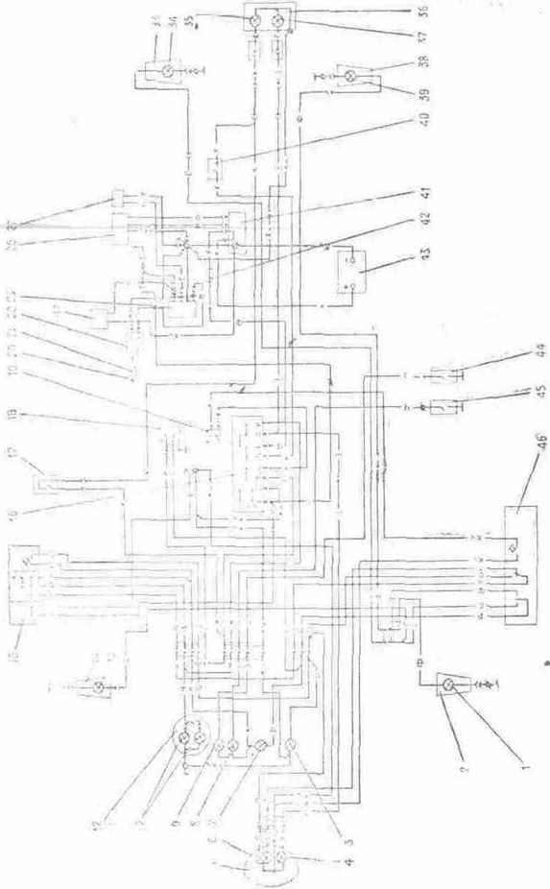

The scheme electrical:
1, 13, 34, 39 - lamp А12-21-3 of a lantern of turn indicators of a motorcycle; 2, 14, 33, 38 - lanterns of the indexes of turns; 3 - indicating light And 12-1 « D. light »; 4 - lamp And 12-4 lay lights; 5 - head lamp; 6 - lamp And 12-45 + 40 distant - short-range lights of a head lamp; 7 - indicating light АМН 12-3-1 turn indicators; 8 - indicating light And 12-1 "Neutral positions"; 9 - indicating light And 12-1 "Oils"; 10 - lamp AMN 12-3-1 illuminations of a speedometer; 11 - speedometer; 12 - shield of devices; 15 - switch combined; 16 - ignition switch; 17 - disconnecting switch of XOFF of the brake of a forward sprocket; 18 - interrupter of turn indicators; 19 - signal sound; 20 - ignition plug; 21 - tip Ignition plug; 22 - induction coil; 23 - switchboard; 26 - generator; 27 - sensor; 35 - lamp A 12-21-3 XOFFs of a motorcycle; 36 - lantern of a back motorcycle; 37 - lamp A 12-5 back overall dimensions of a motorcycle; 40 - disconnecting switch of XOFF of the brake of a back sprocket; 41 - rectifier - voltage regulator BPV 21-15; 41 and - voltage regulator RNM-1; 42 - safety device; 43 - battery accumulative; 44 - valve - sensor of submission of oil; 45 - disconnecting switch of a lamp "Neutral position"; 46 - switch of the signalling system; 47 - condenser K50-35-63В-2200 mF-V
Notation of paint of wires:
Г - blue; - yellow; 3 - green; K - red; Кч - brown; O - orange; Р - pink; C - grey; Ф - violet; Ч - black
The notice. On a motorcycle with a lateral trailer the hooking up of a lantern of a back lateral trailer implements in the connector green and red wires going to a lantern of a back motorcycle

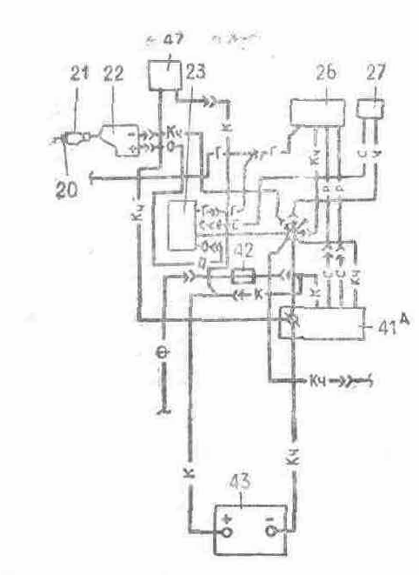
The scheme of hooking up of RIM 1

The appendix 8. The scheme of the engine

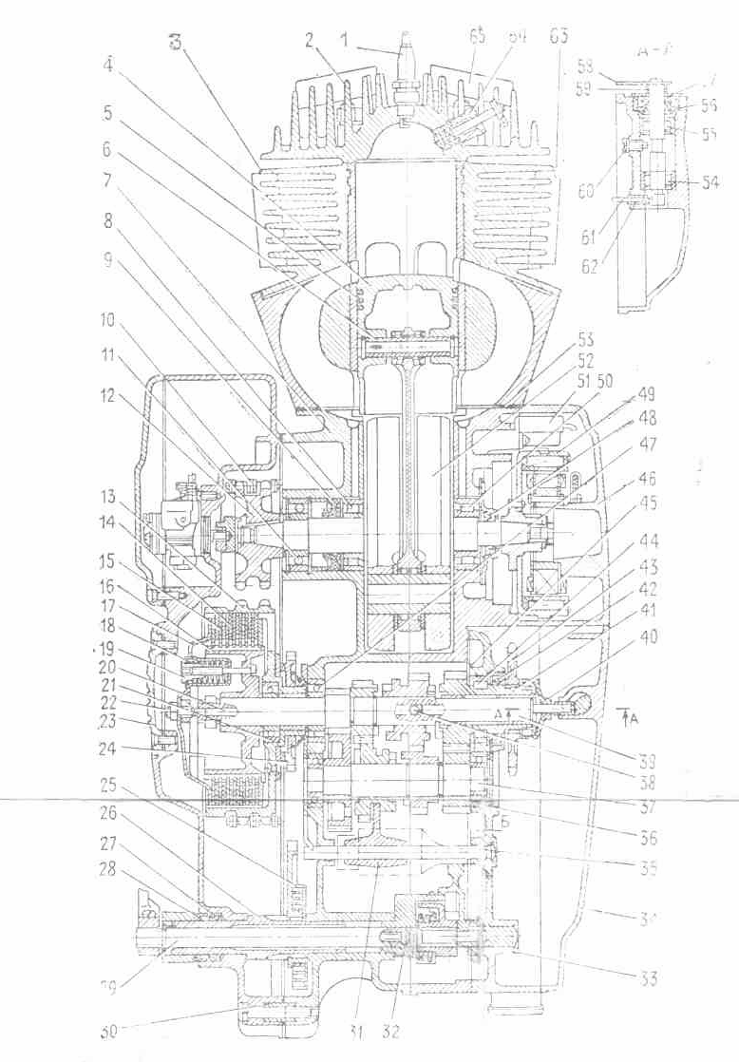
The engine with a gear box in a cut:
1 - ignition plug; 2 - head of the barrel; 3 - barrel; 4 - cylinder piston; 5 - piston ring; 6 - pin piston; 7 - casing; 8 - cone bearing; 9 - left-hand gland; 10 - motor circuit; 11 - ball-bearing; 12 - sprocket of a crankshaft; 13 - outside barrel of a clutch; 14 - disk leading; 15 - disk a wingman; 16 - internal barrel; 17? - compression disk; 18 - spring; 19 - shaped nut; 20 - thruster; 21 - ball-bearing; 22 - screw adjusting with a lock nut; 23 - cover of the hatch; -24 - cog-wheel kick-starter; 25 - spring; 26 - arbor of a releaser; 27 - sealing ring; 28 - reflector: 29 - arbor of the gear of switching; 30 - customizing bush; 31 - shirt control fork; 32 - emphasis; 33 - cover of a gear box; 34 - dextral cover; 35 - gear operating shaft; 36 - ball-bearing; 37 - jackshaft with cones: 38 - bead (5,556 mms); 39 - primary arbor with cones; 40 - cap of a nut of the secondary arbor; 41 - secondary arbor; 42 - sealing ring; 43 - sprocket; 44 - cone bearing; 45 - cone of the secondary arbor; 46 - cover of the generator with a stator; 47 ball-bearings; 48 - dextral gland; 49 - rotary table of the generator; 50 - cone bearing; 51 - sensor of ignition; 52 - crankshaft; 53 - cylinder ring; 54 - bearing box spicular;. 55 - bearing box spicular; 56 - sealing ring; 57 - spacer; 58 - lever cutoffs of coupling; 59 - spring reflexive; 60 - screw persistent; -61 - thruster; 62 - sleeve; 63 - vibration damper; 64 - decompressor; 65 - vibration damper

